Excel Class-4

| Table of content:  Agenda:  Dataset used for the class:  Business Problem: Create a dashboard by analyzing the fitbit raw data and provide insights on activities across various parts of the day  Steps to develop Dashboard:  Filter Vs Slicer in Pivot Table:  Detailed Notes for Dashboard Development:  1. Data Preparation: Create 4 columns:  2. Chart Creation  3. Dashboard Creation |
| --- |

### Agenda:

* Developing a dashboard in Excel
* Introduction to slicer
* Recording a Macro

### Dataset used for the class:

Raw Data: [Fitbit Raw Data.xlsx](https://docs.google.com/spreadsheets/d/1tR1yBt58LqmOP-MWwm9uyPKkuEpNtnNs/edit?usp=sharing&ouid=107681937864127182413&rtpof=true&sd=true)

Solution: [Fitbit Raw Data Live class solution.xlsx](https://docs.google.com/spreadsheets/d/1J51WmNM1bPNaSjdw7ztzNqvOYT_a73wS/edit?usp=sharing&ouid=107681937864127182413&rtpof=true&sd=true)

### 

### Business Problem: Create a dashboard by analyzing the fitbit raw data and provide insights on activities across various parts of the day

### Steps to develop Dashboard:

* Data Preparation
* Chart Creation
* Dashboard Creation

### Filter Vs Slicer in Pivot Table:

In a pivot table, both filters and slicers are used to narrow down the data that is displayed in the pivot table, but they work in slightly different ways:

1. Filter: A filter in a pivot table is used to exclude data from the pivot table. Filters are set up by selecting a column and specifying the criteria that must be met for the data in that column to be displayed in the pivot table. For example, you might create a filter to display only sales data for a particular region or for a certain time period.
2. Slicer: A slicer in a pivot table is similar to a filter in that it is used to narrow down the data that is displayed in the pivot table. **However, a slicer is a visual tool that allows you to quickly filter data by clicking on an interactive element, such as a dropdown menu or a button.** Slicers are typically placed next to the pivot table, and they are often used to filter data by category, such as by product, by customer, or by region.

In summary, filters are used to exclude data based on specific criteria, whereas slicers provide an interactive way to quickly filter data by category.

### Detailed Notes for Dashboard Development:

#### Data Preparation: Create 4 columns:

* **Distance Miles:** Convert the “Distance Meters” to “Distance Miles” using formula: **CONVERT(C2,"m","mi")** and dragging the formula to entire column

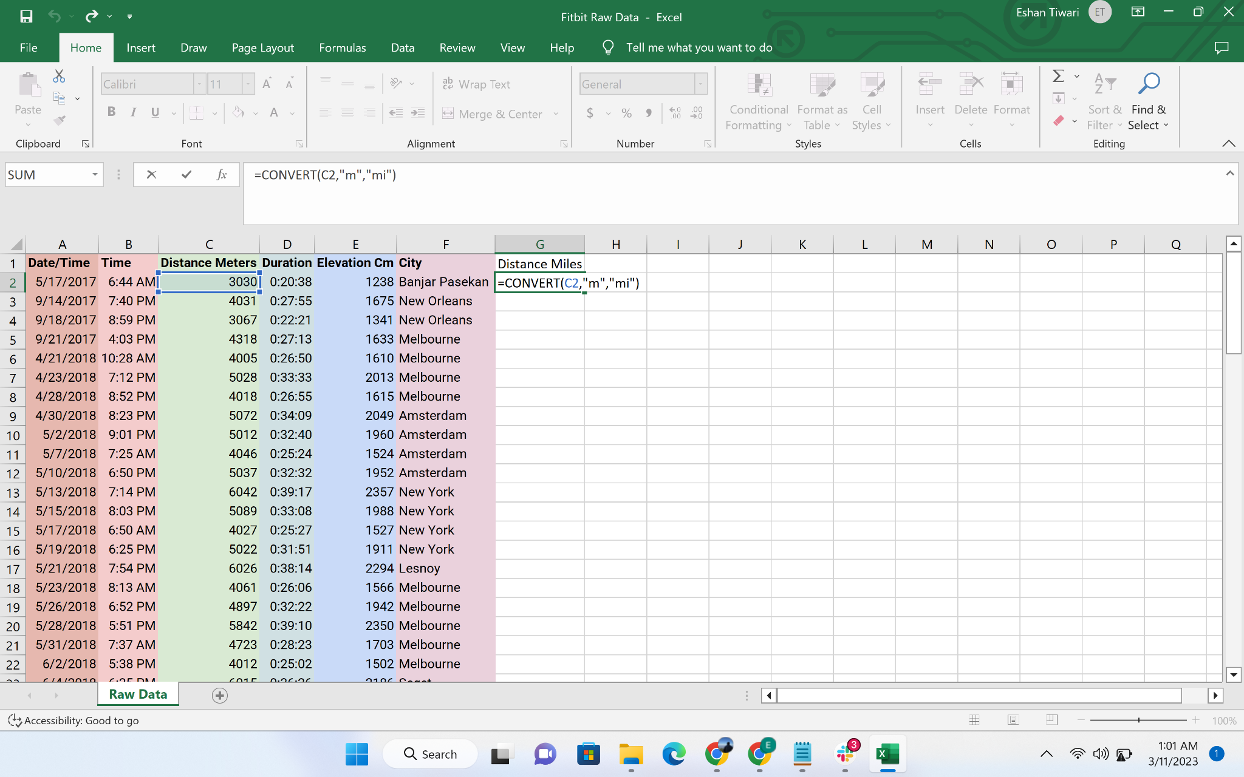

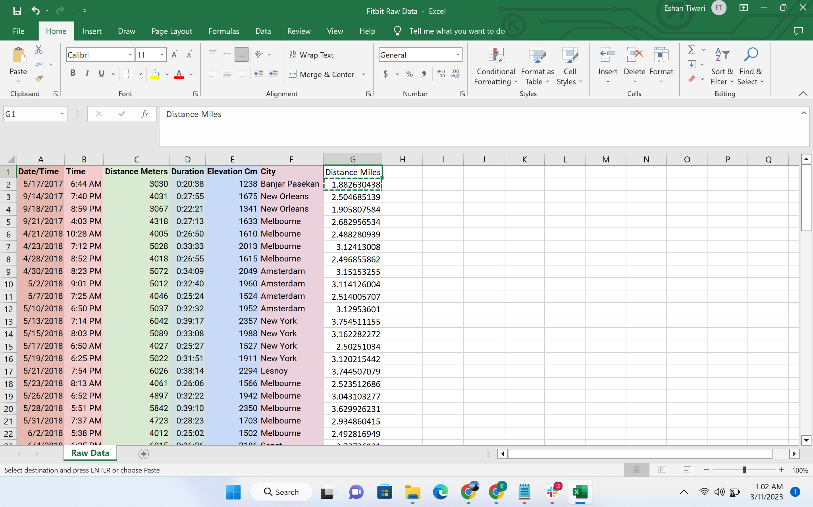

* **ELevation Feet:** Convert the “Elevation Cm” to “Elevation Feet” using formula: **CONVERT(E2,"cm","ft")** and dragging the formula to entire column

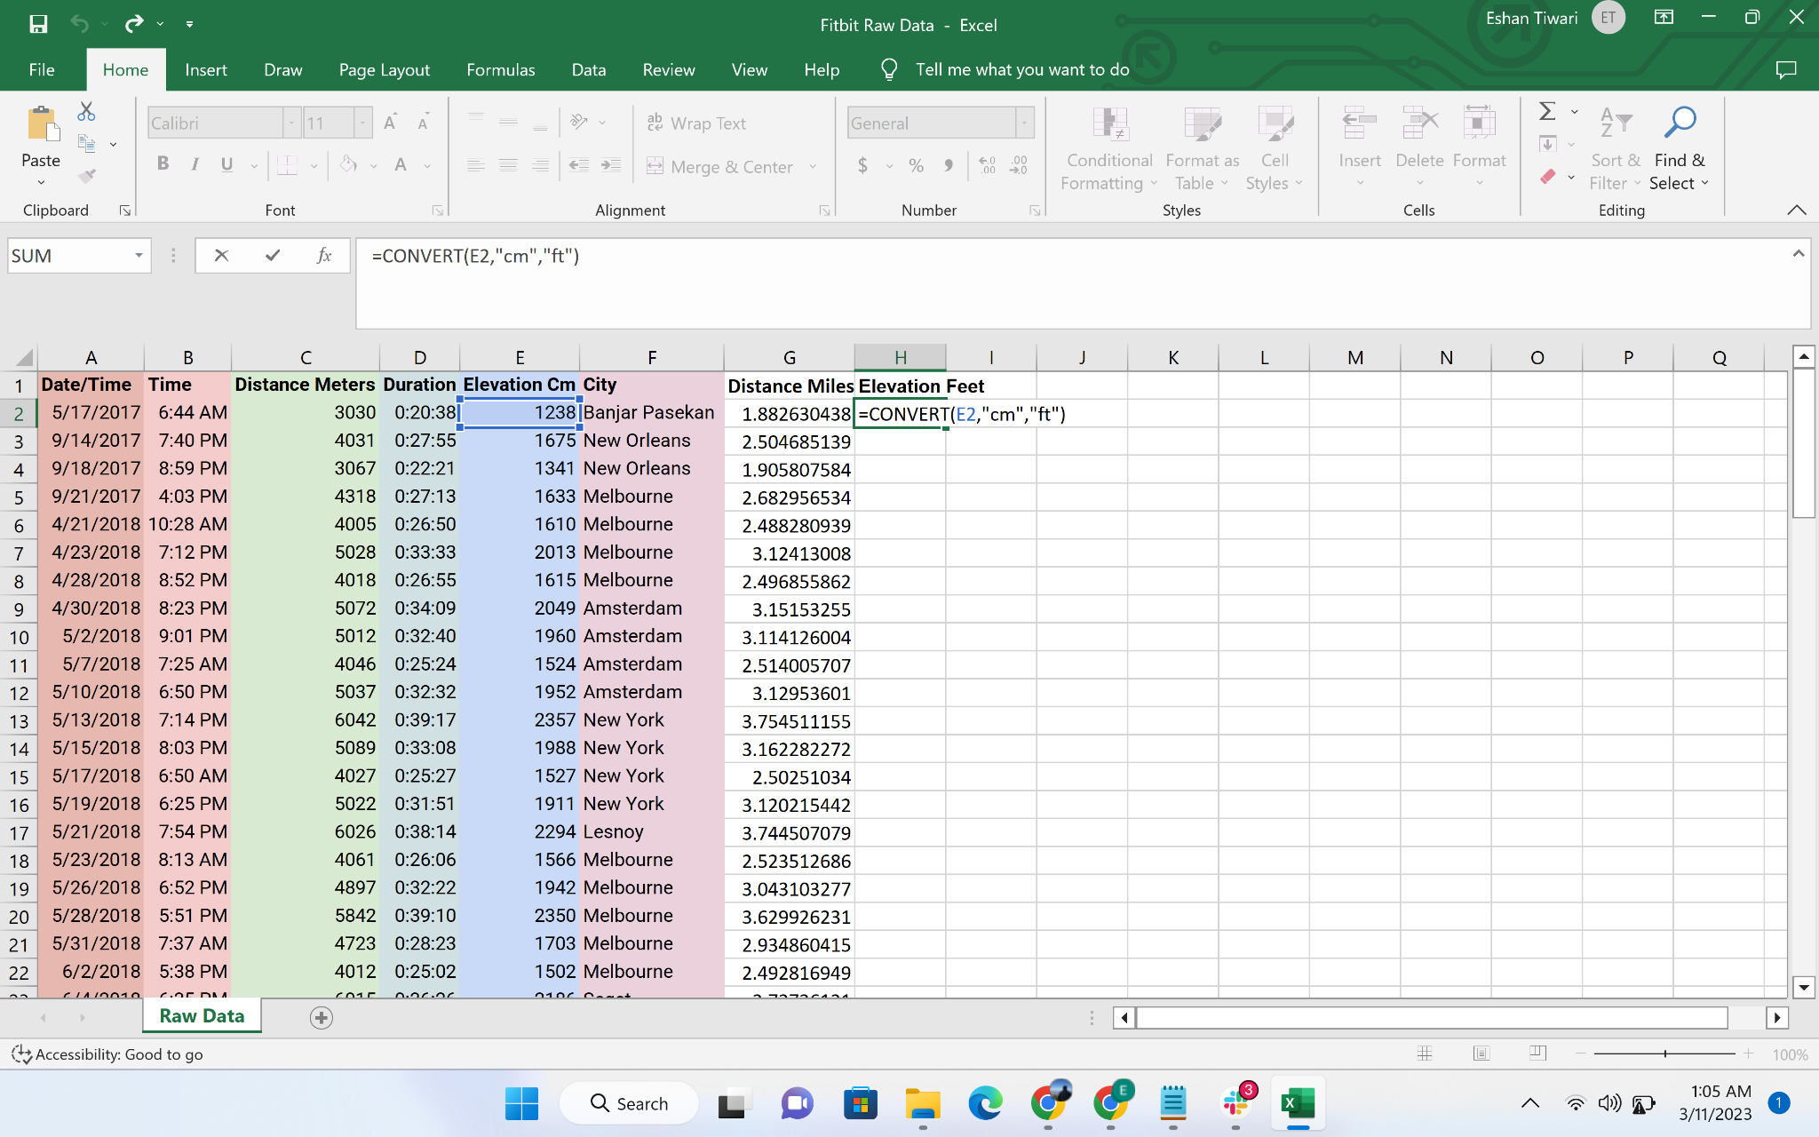

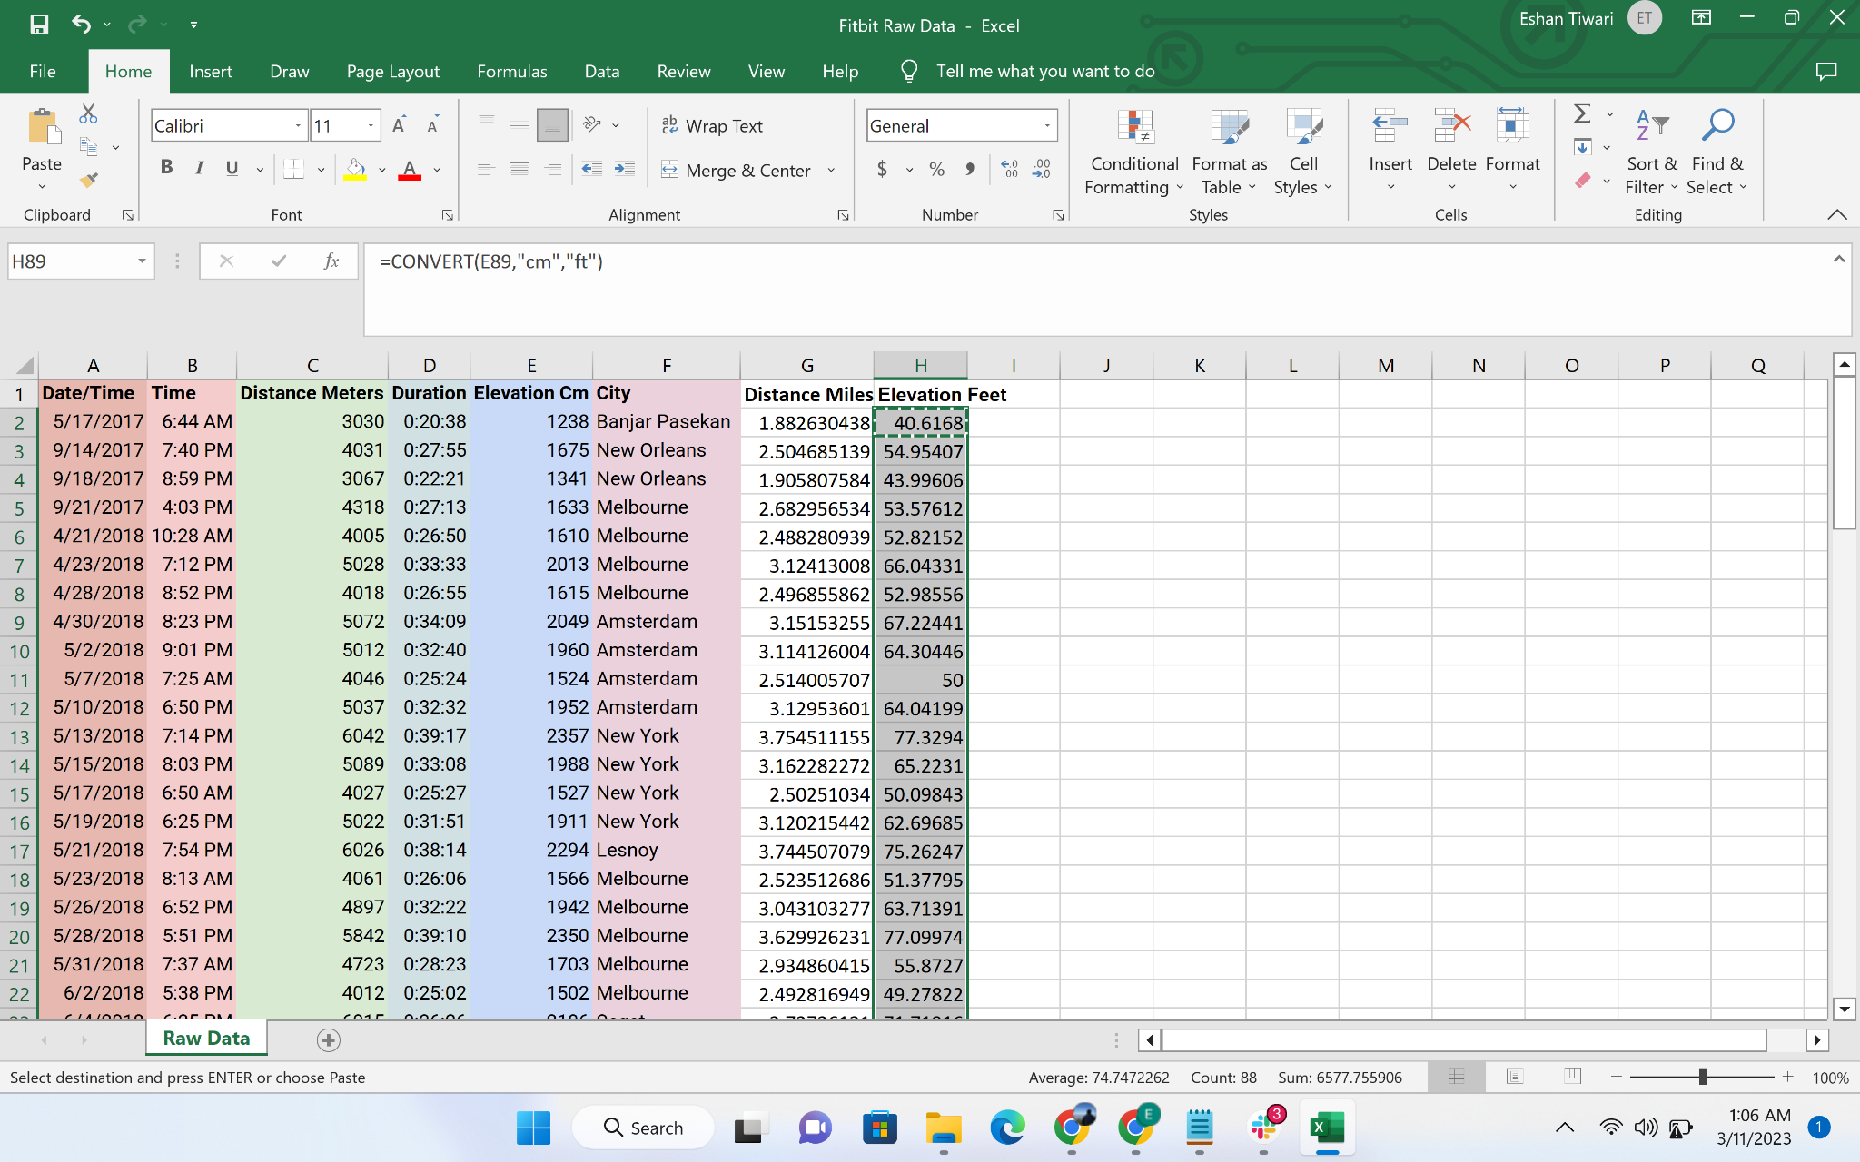

* **Pace(Mins Per Mile):** Create the new column by using formula **D2/G2** and dragging the formula to entire column

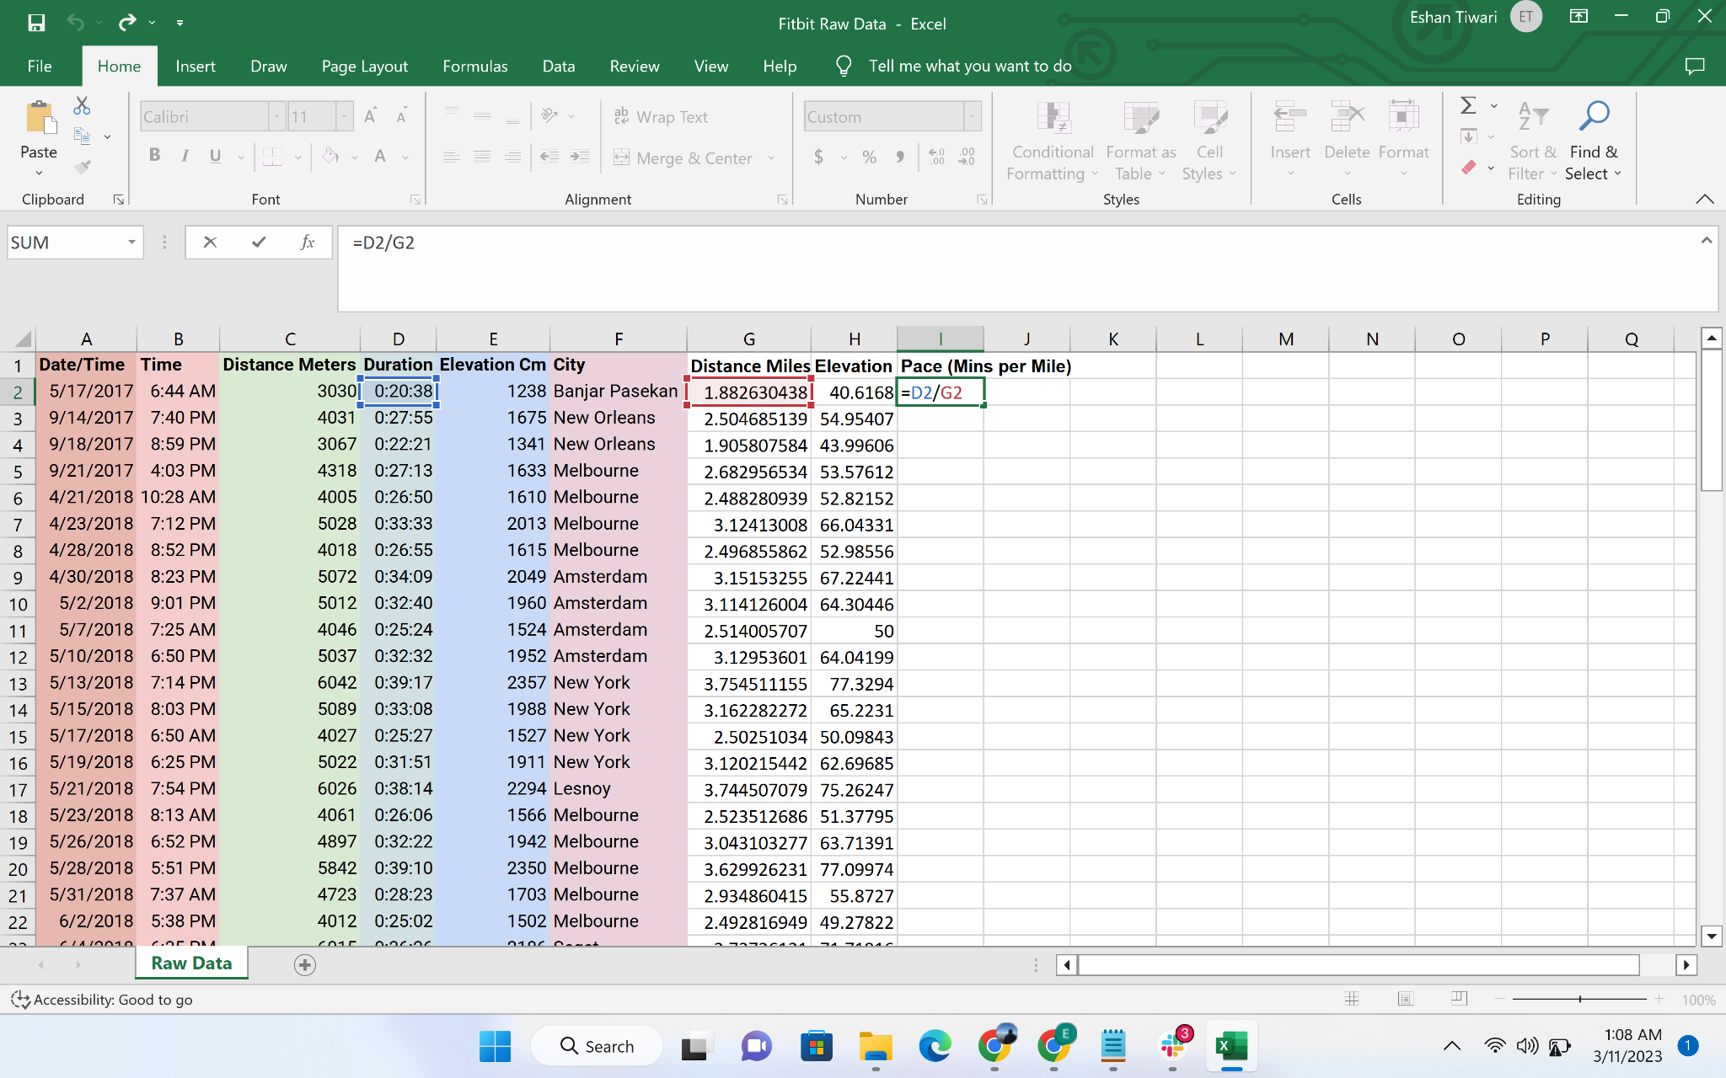

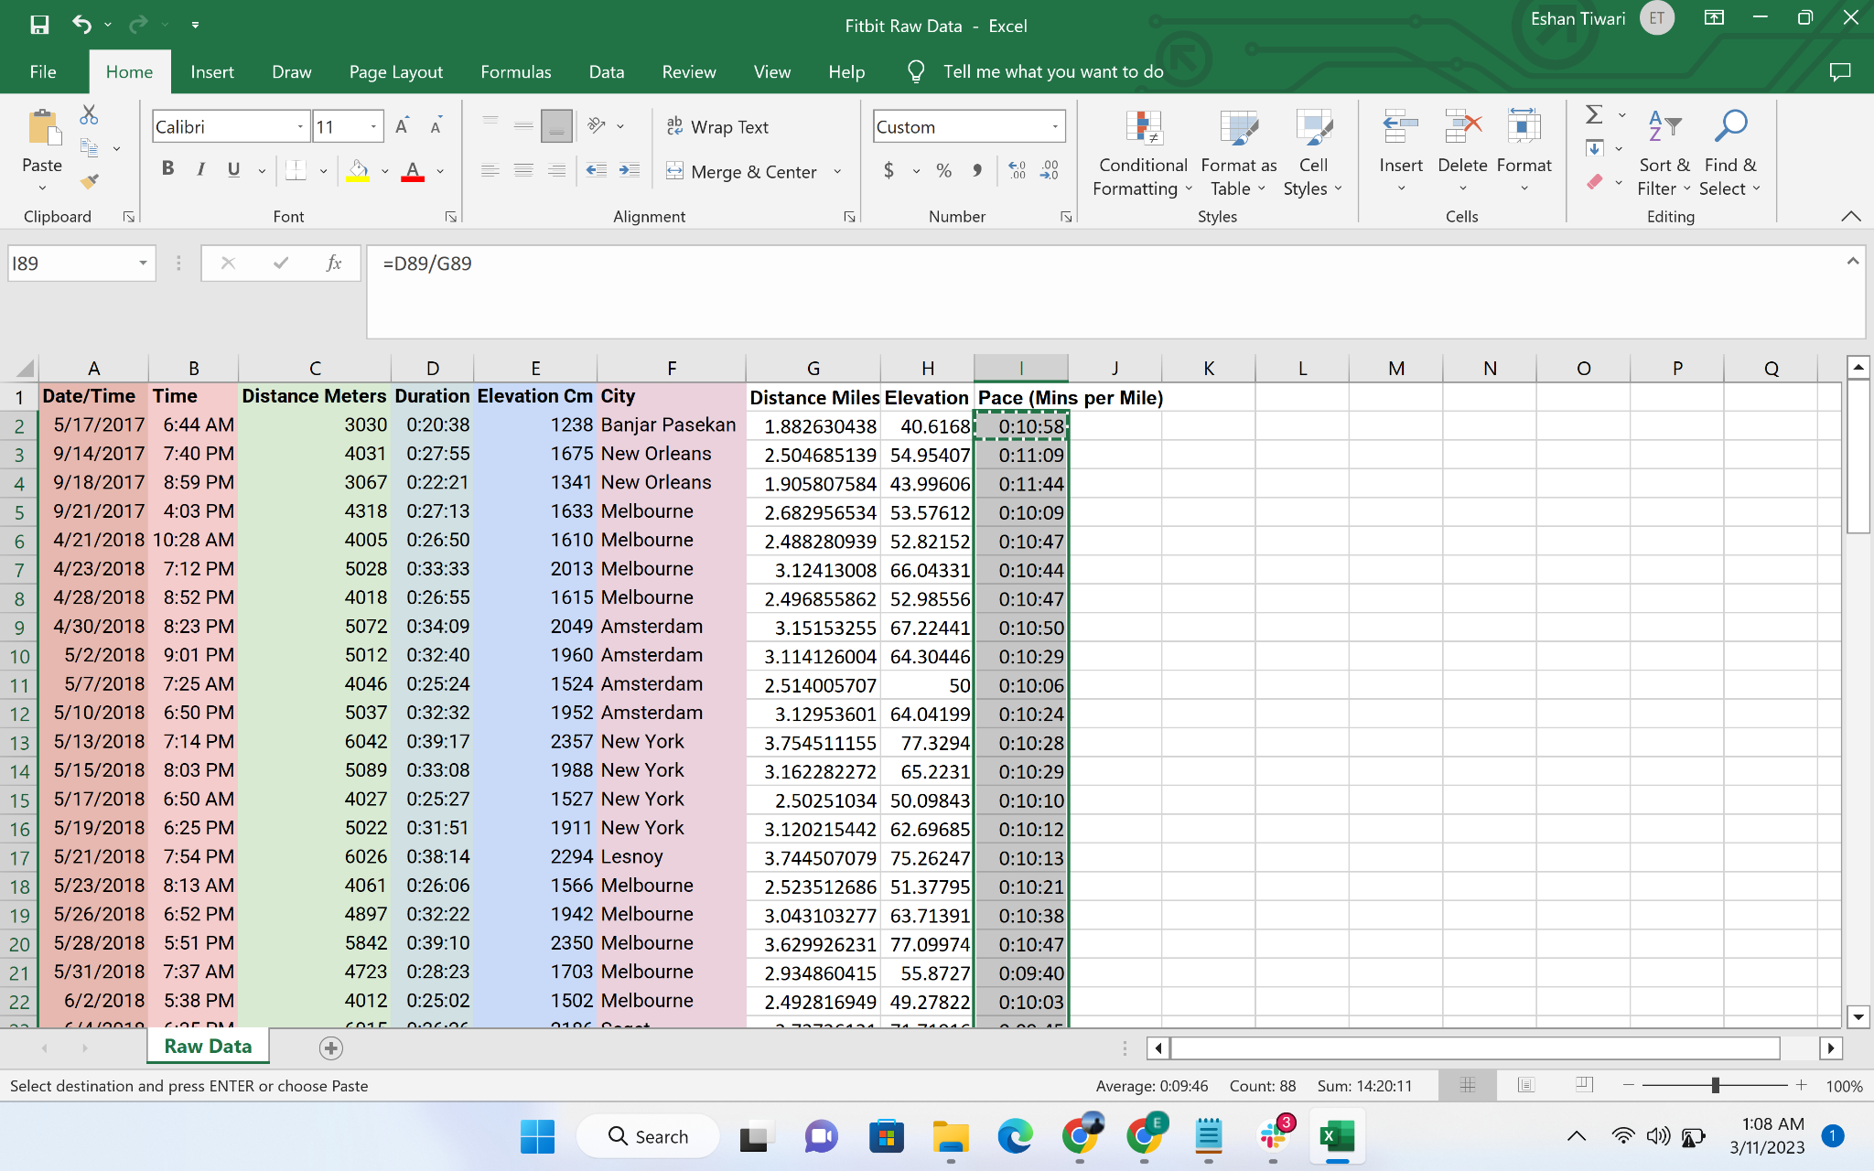

* Type (M/A/E/N): Create a column to identify if an activity is performed in morning, afternoon, evening, night.
  + Morning(M): 12 AM(midnight) - 12 Noon (Excluding)
  + Afternoon(A): 12 PM - 6 PM (Excluding)
  + Evening(E): 6 PM - 9 PM (Excluding)
  + Night (N): 9 PM - 12 AM (midnight) (Excluding)
  + Use the following formula to calculate the **Type column: IF(J2<12,"M",IF(J2>18,"E","A"))** and drag the formula across the column

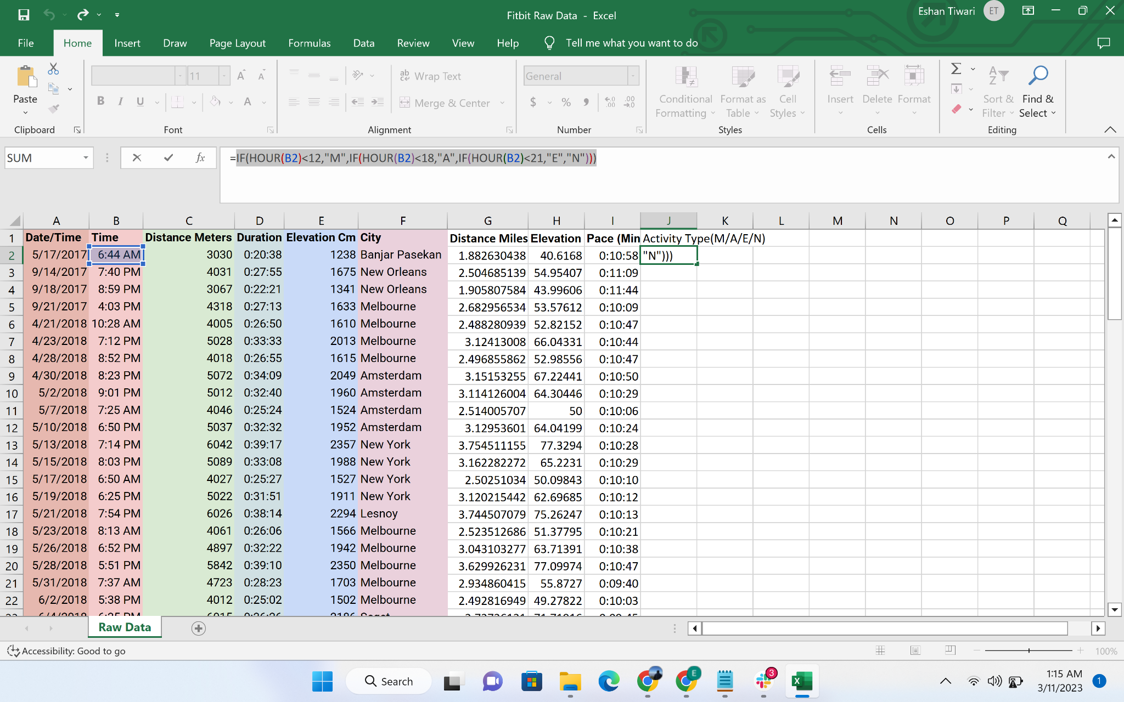

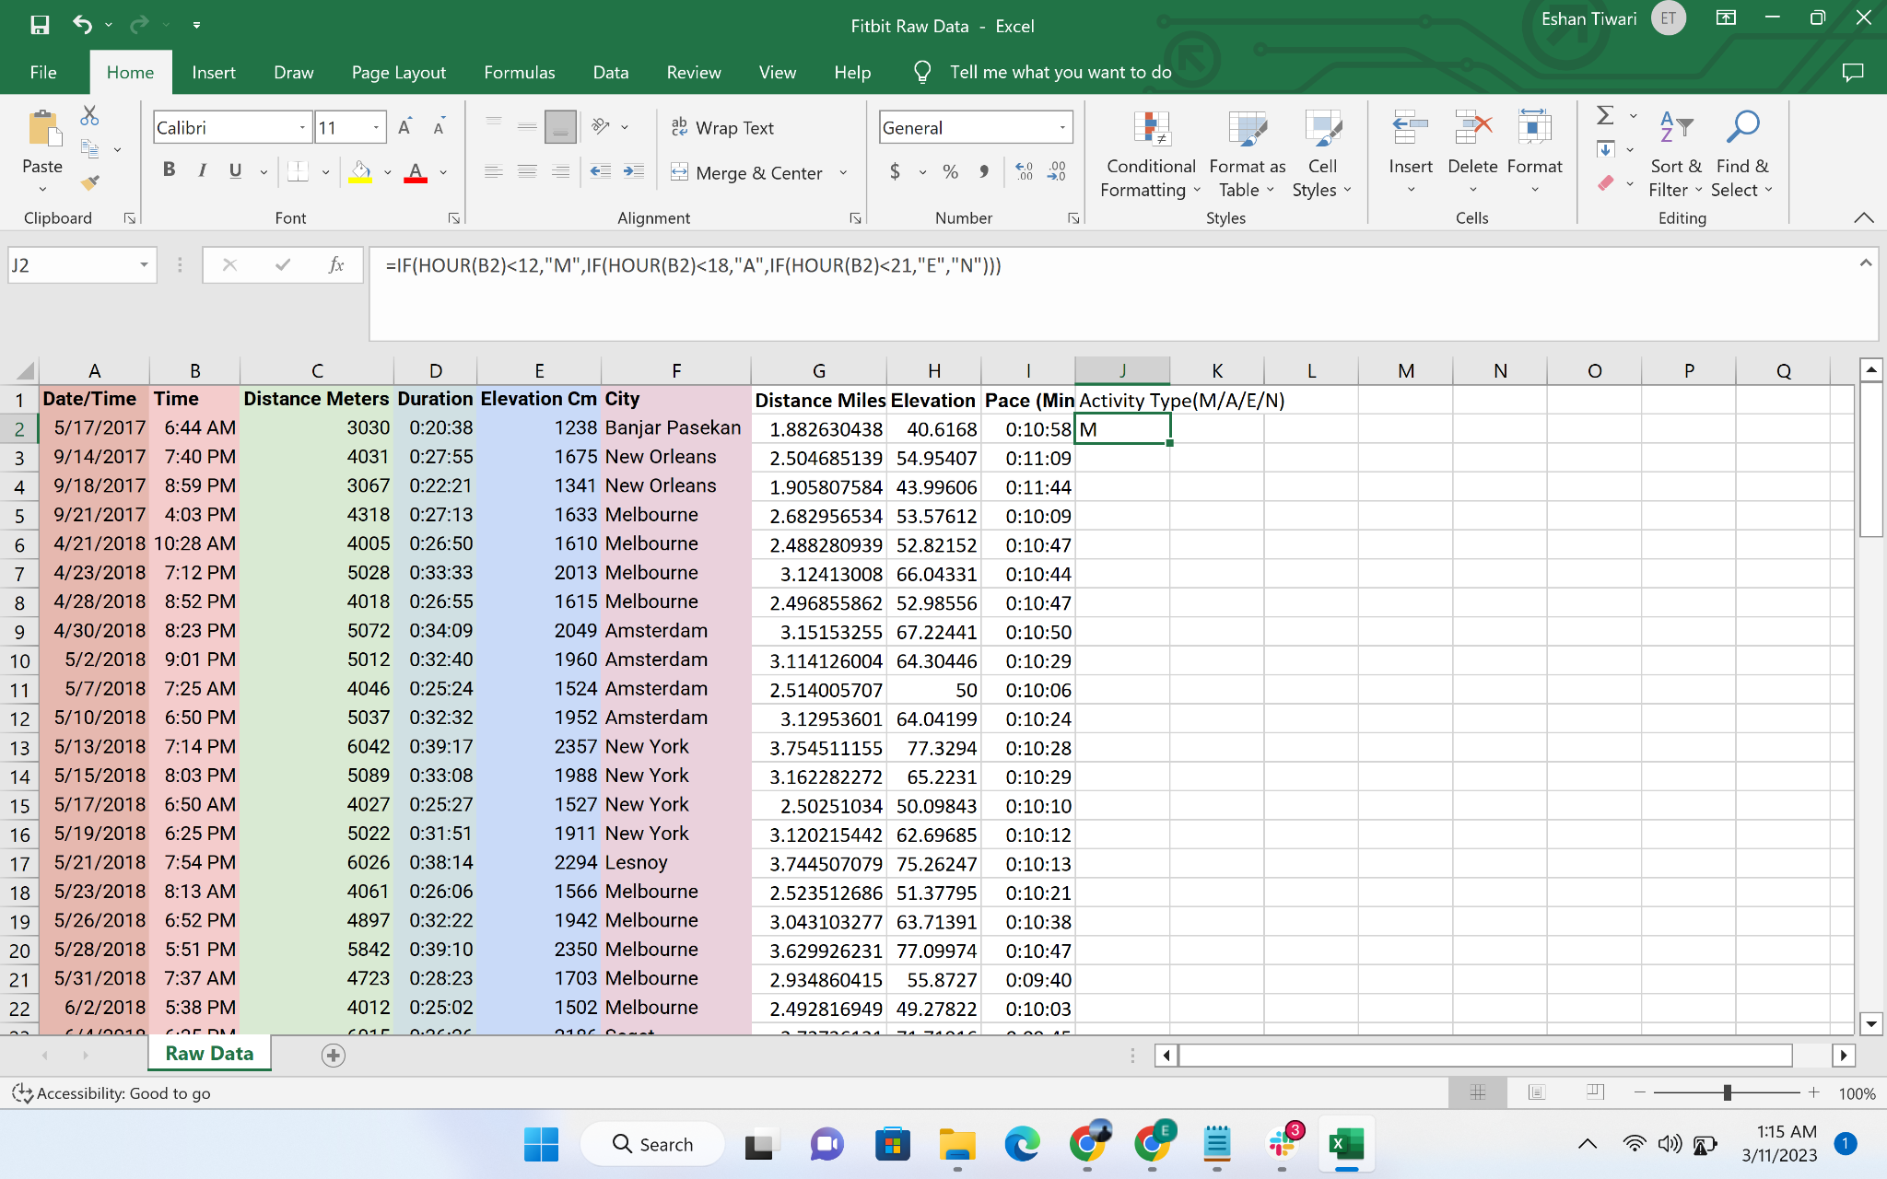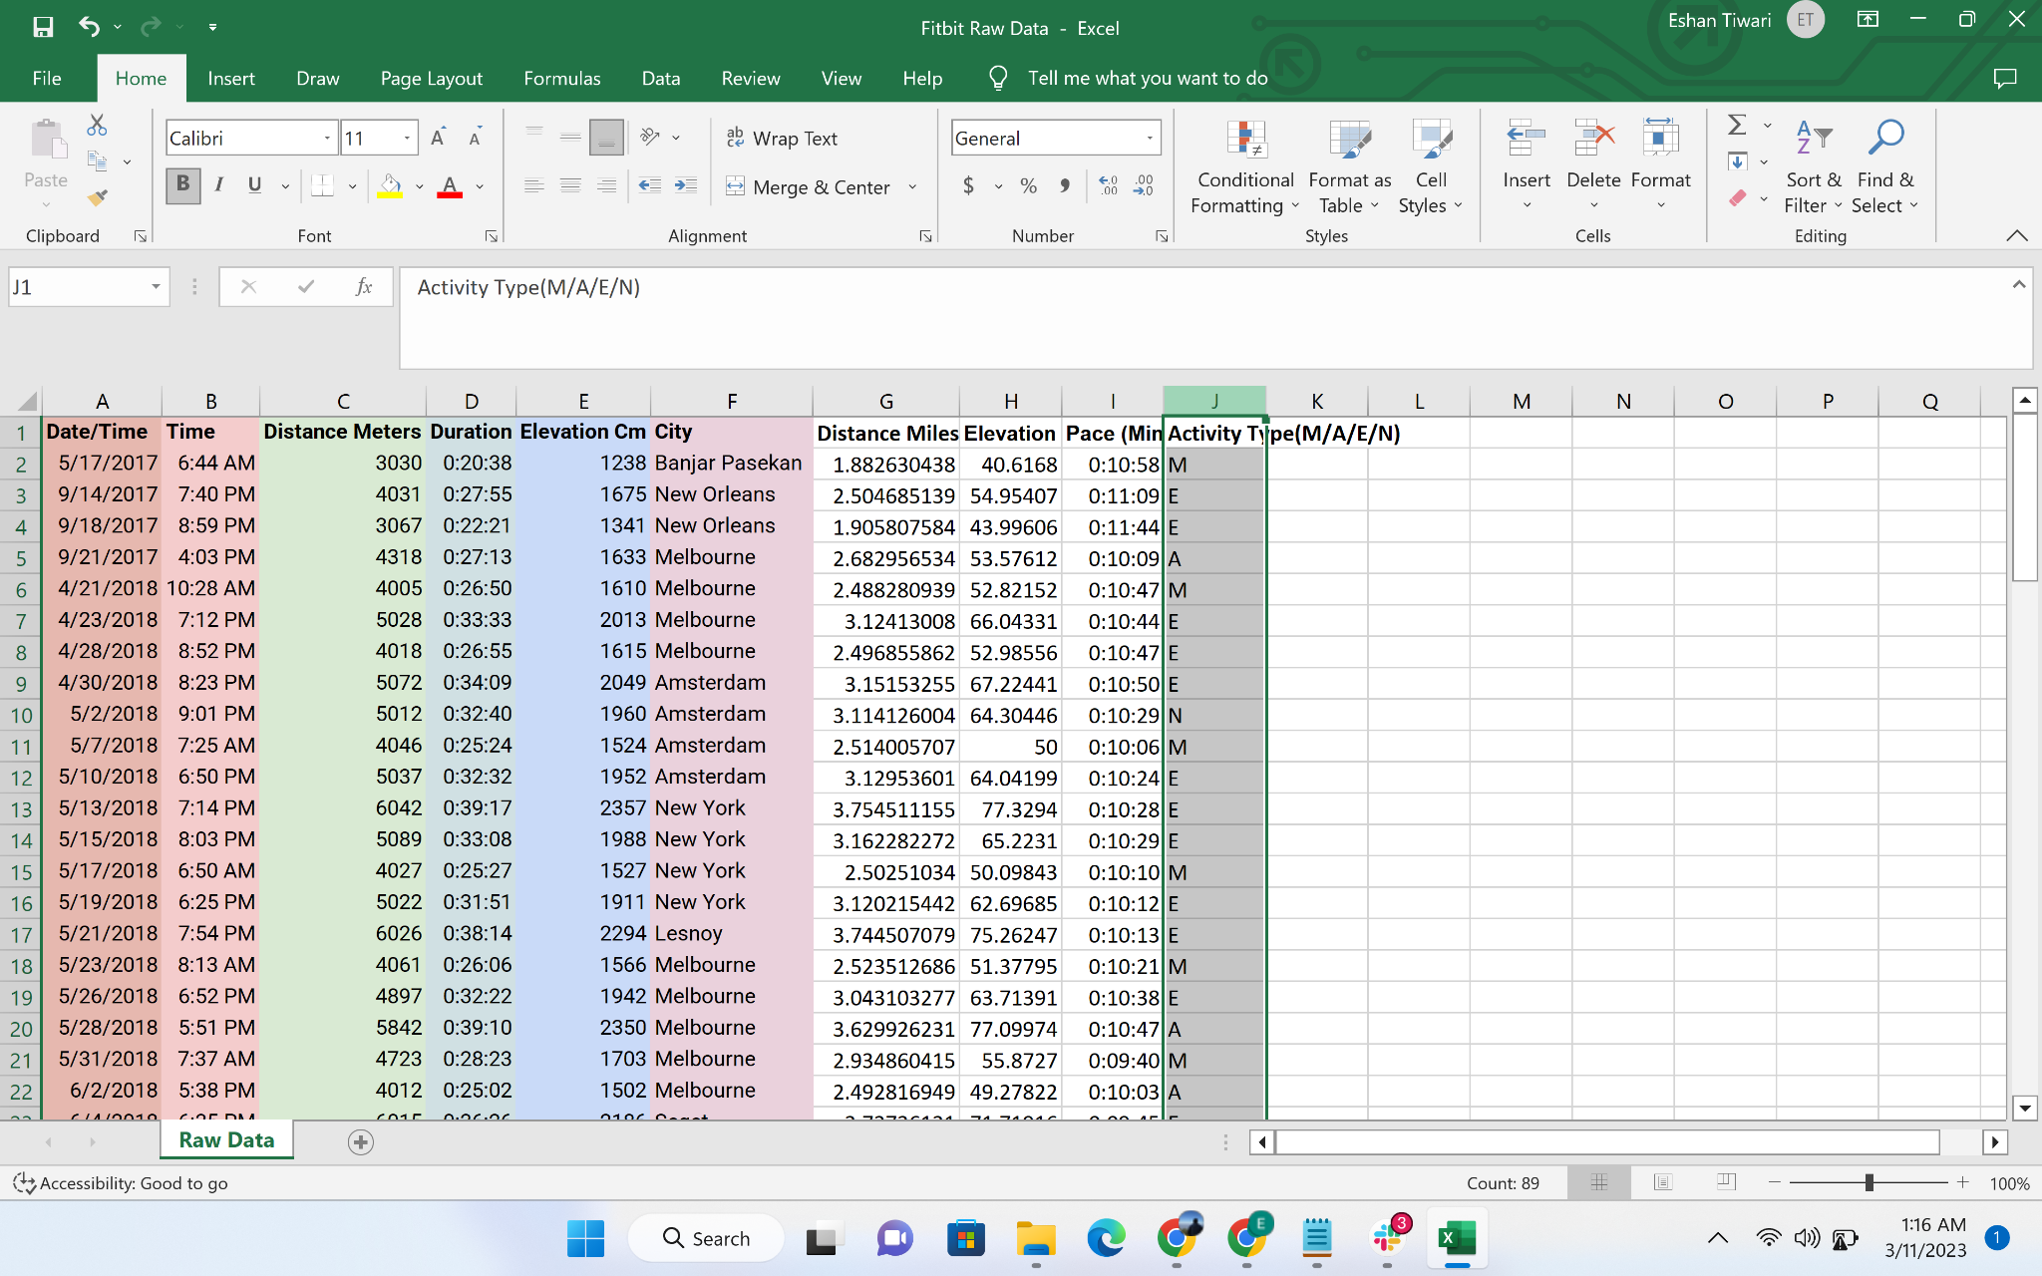

#### Chart Creation

* + Create pivot table for entire dataset in a new worksheet

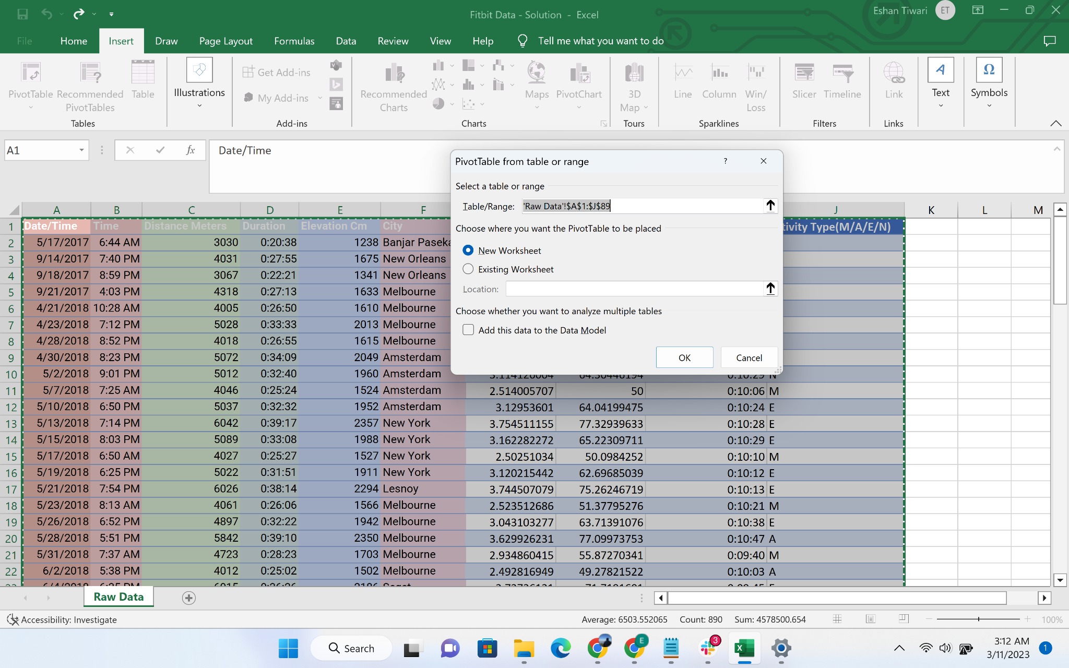

* Create a summary table for each Type including following columns:
  + Number of cities
  + Total distance
  + Avg pace
  + Average elevation Feet

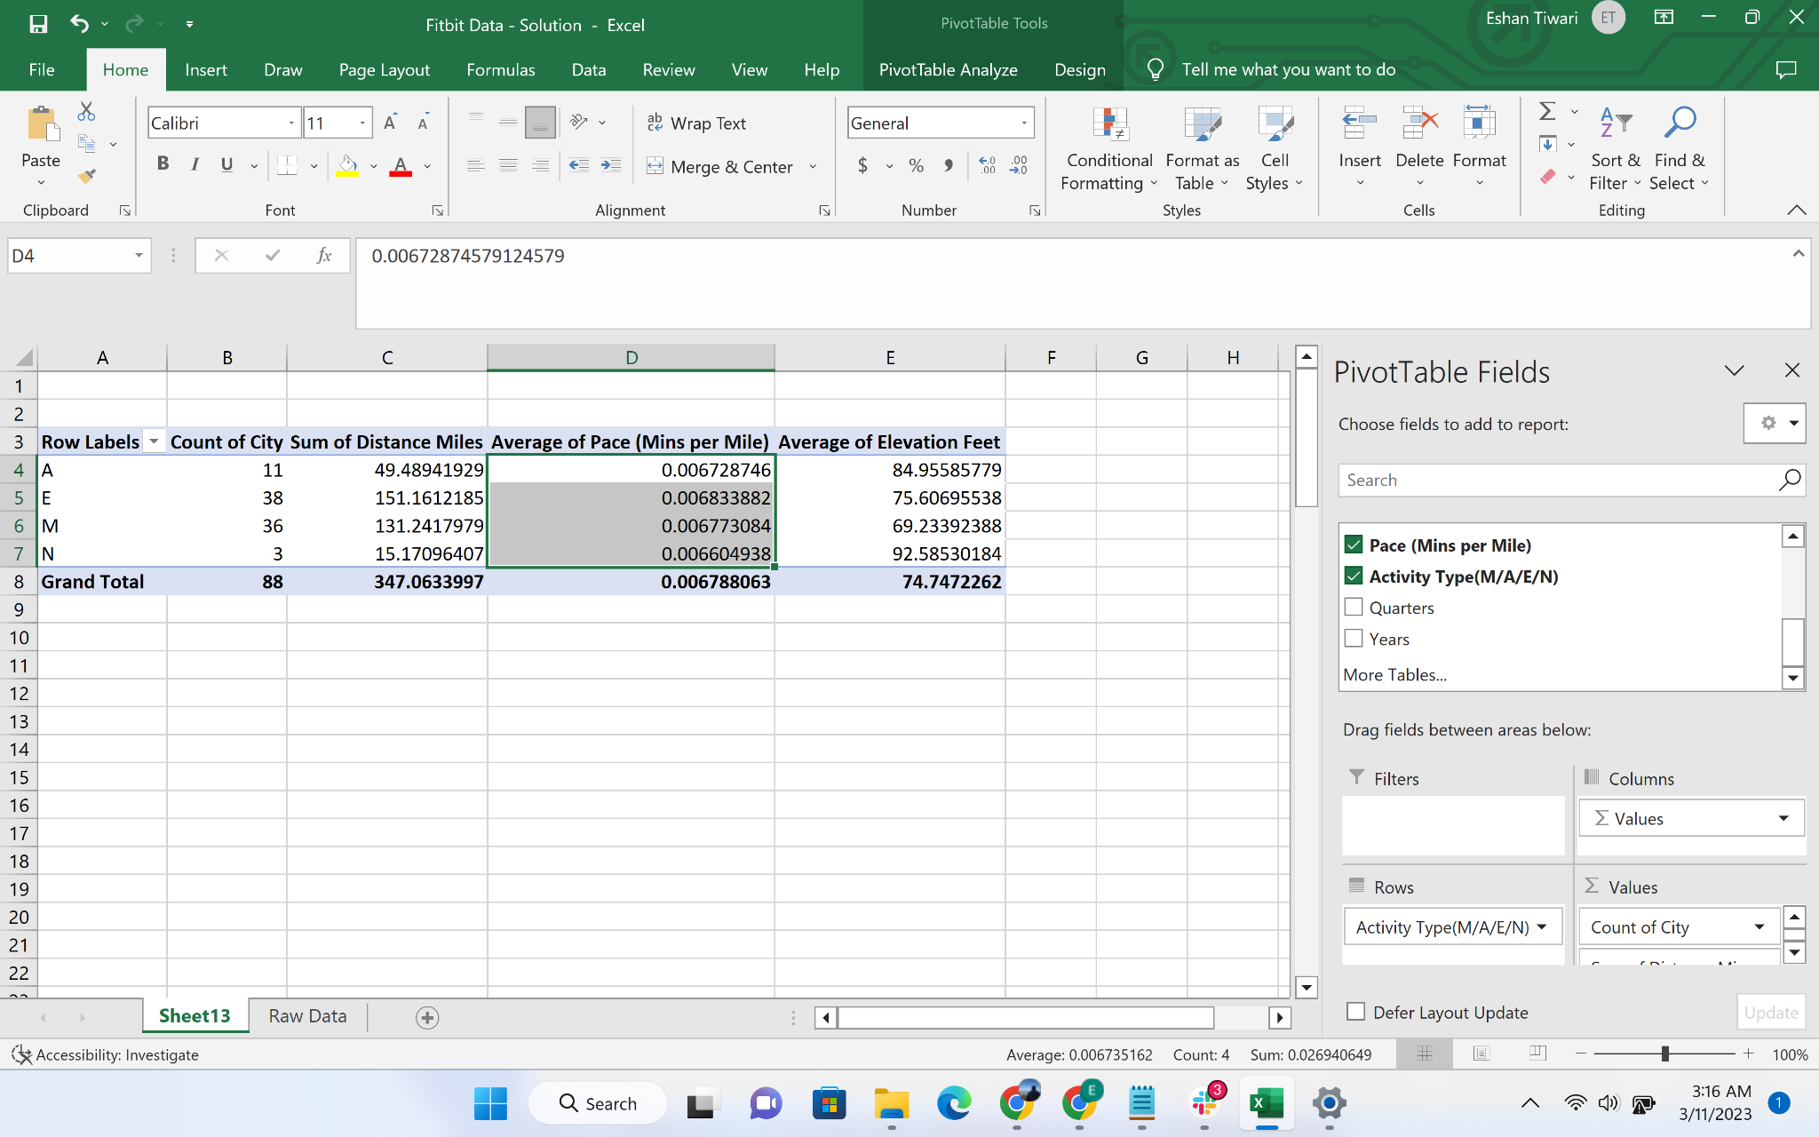

* Change the data types for average pace

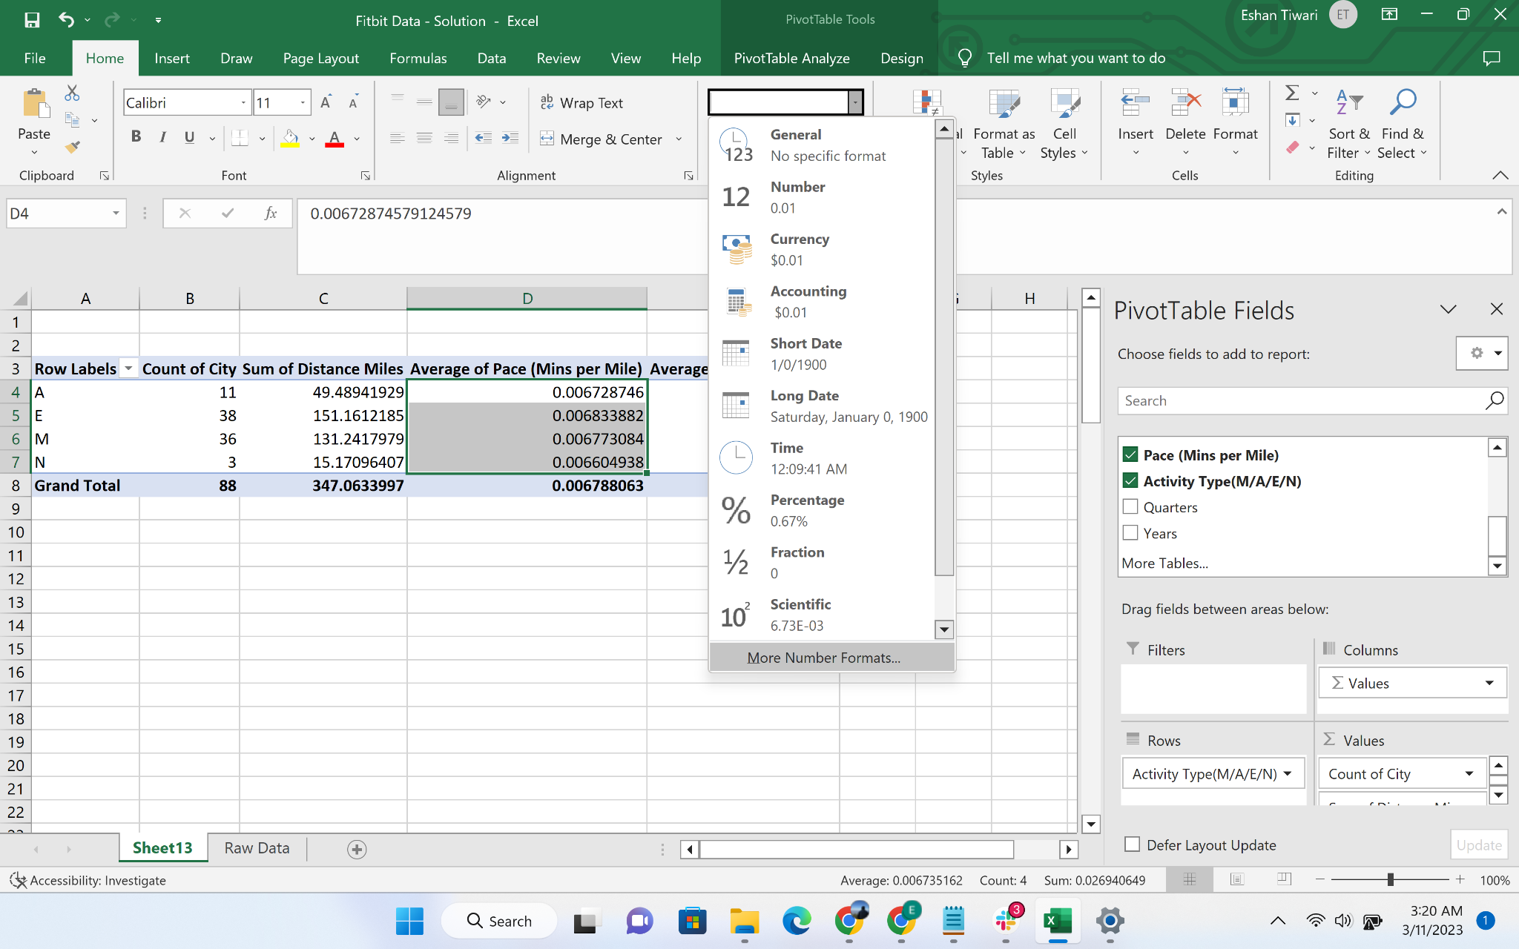

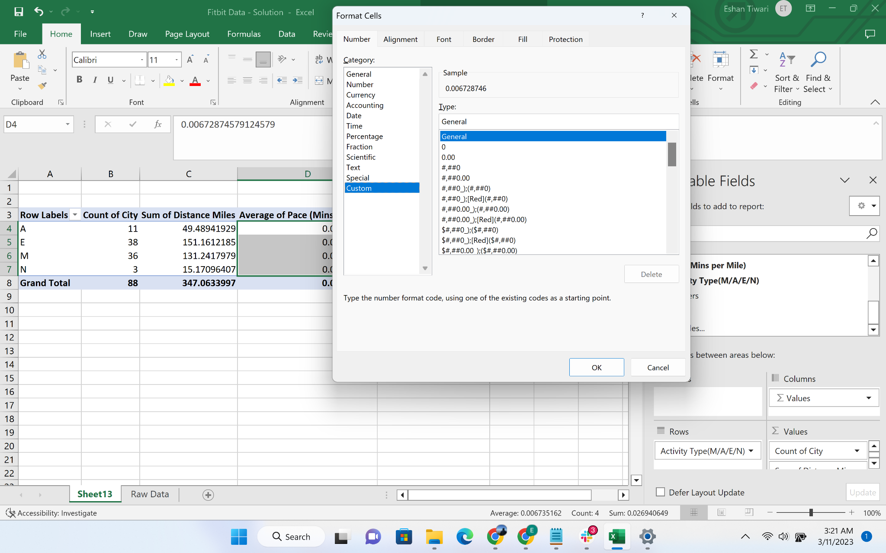

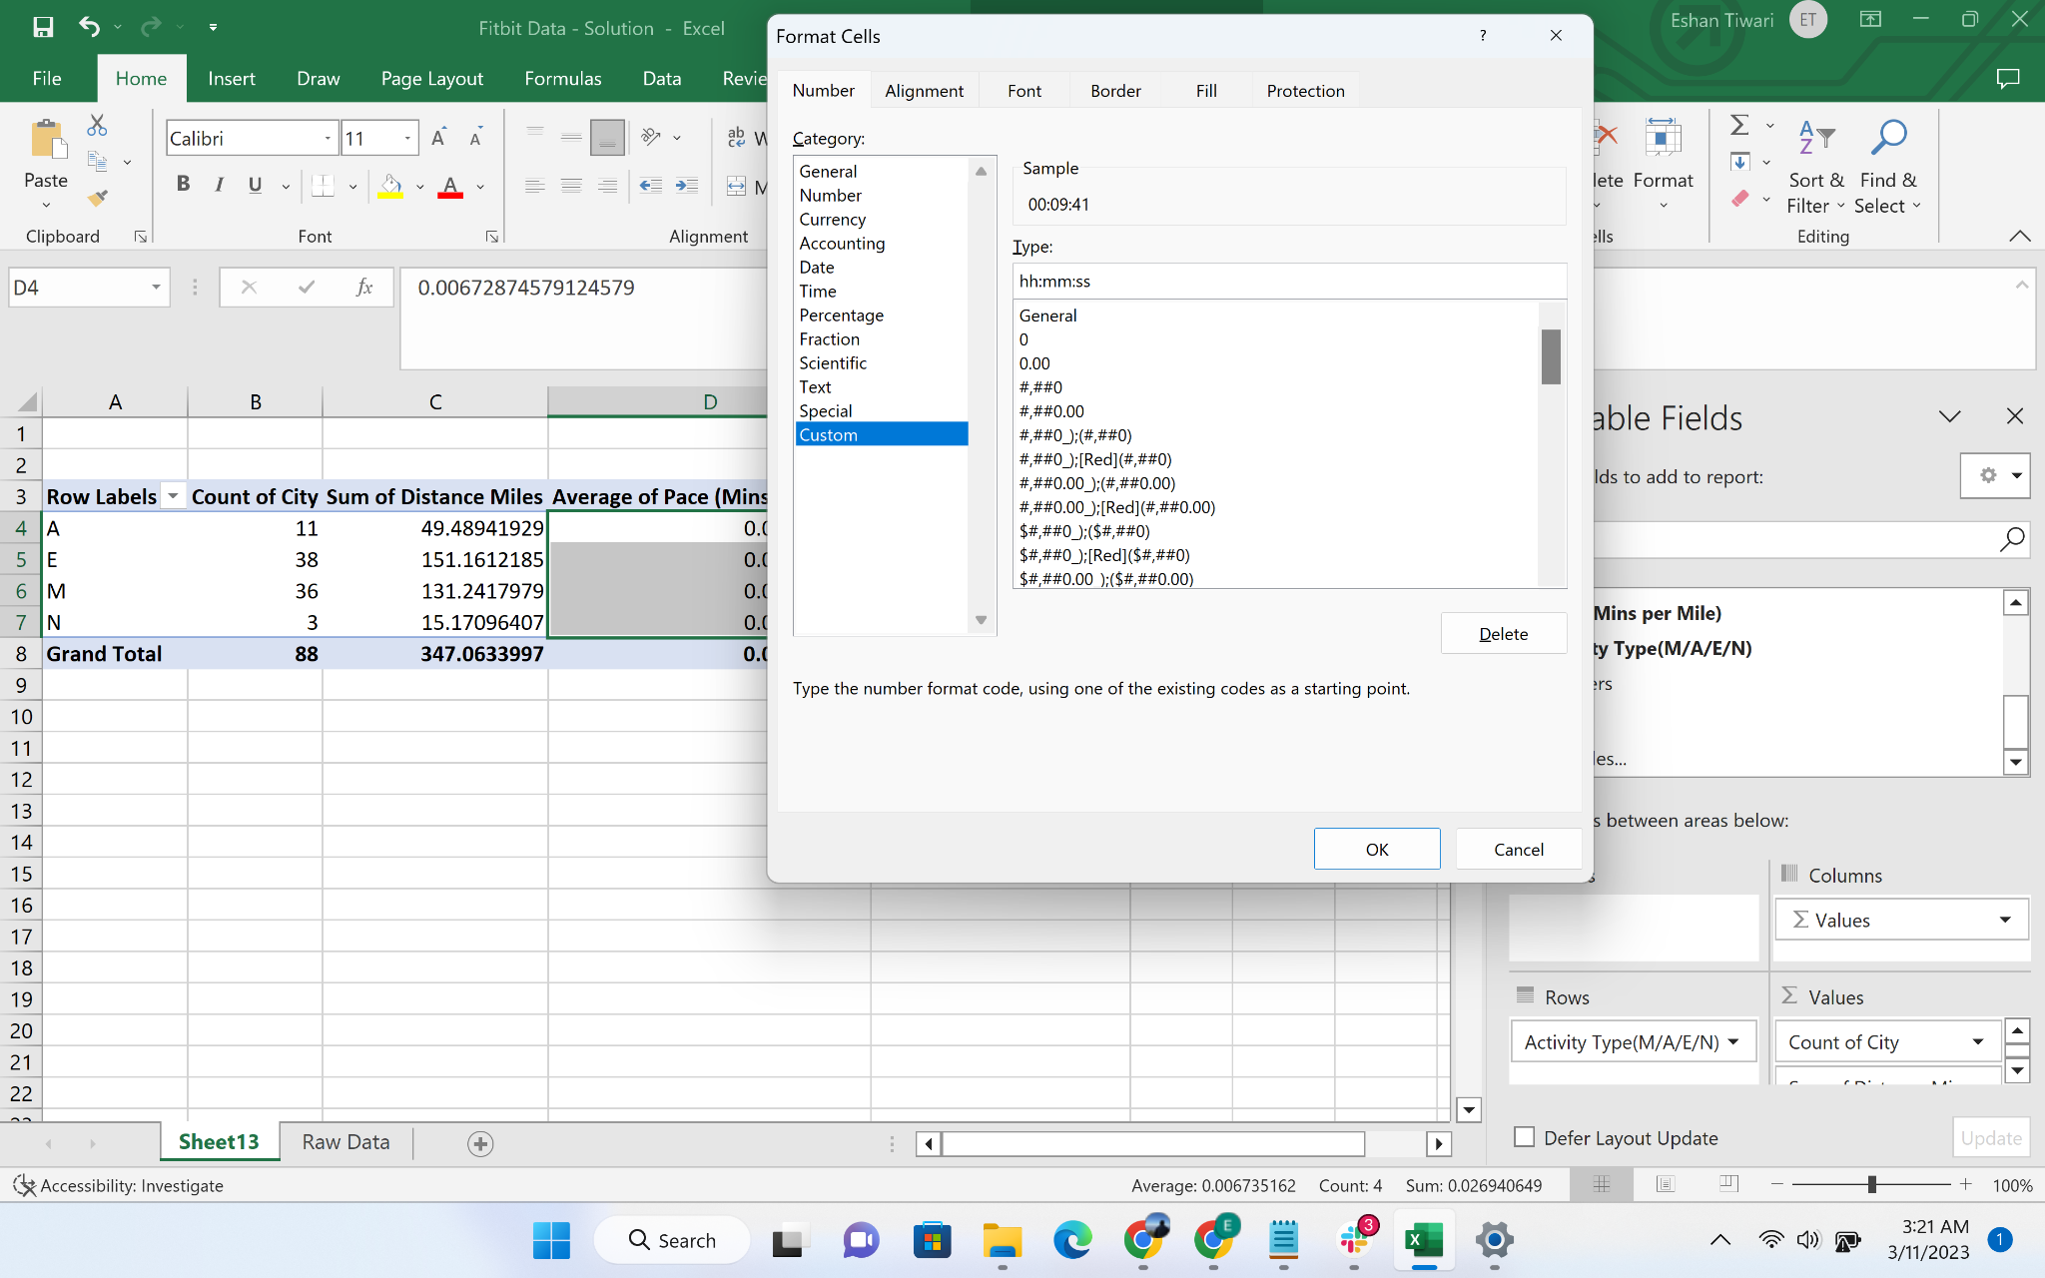

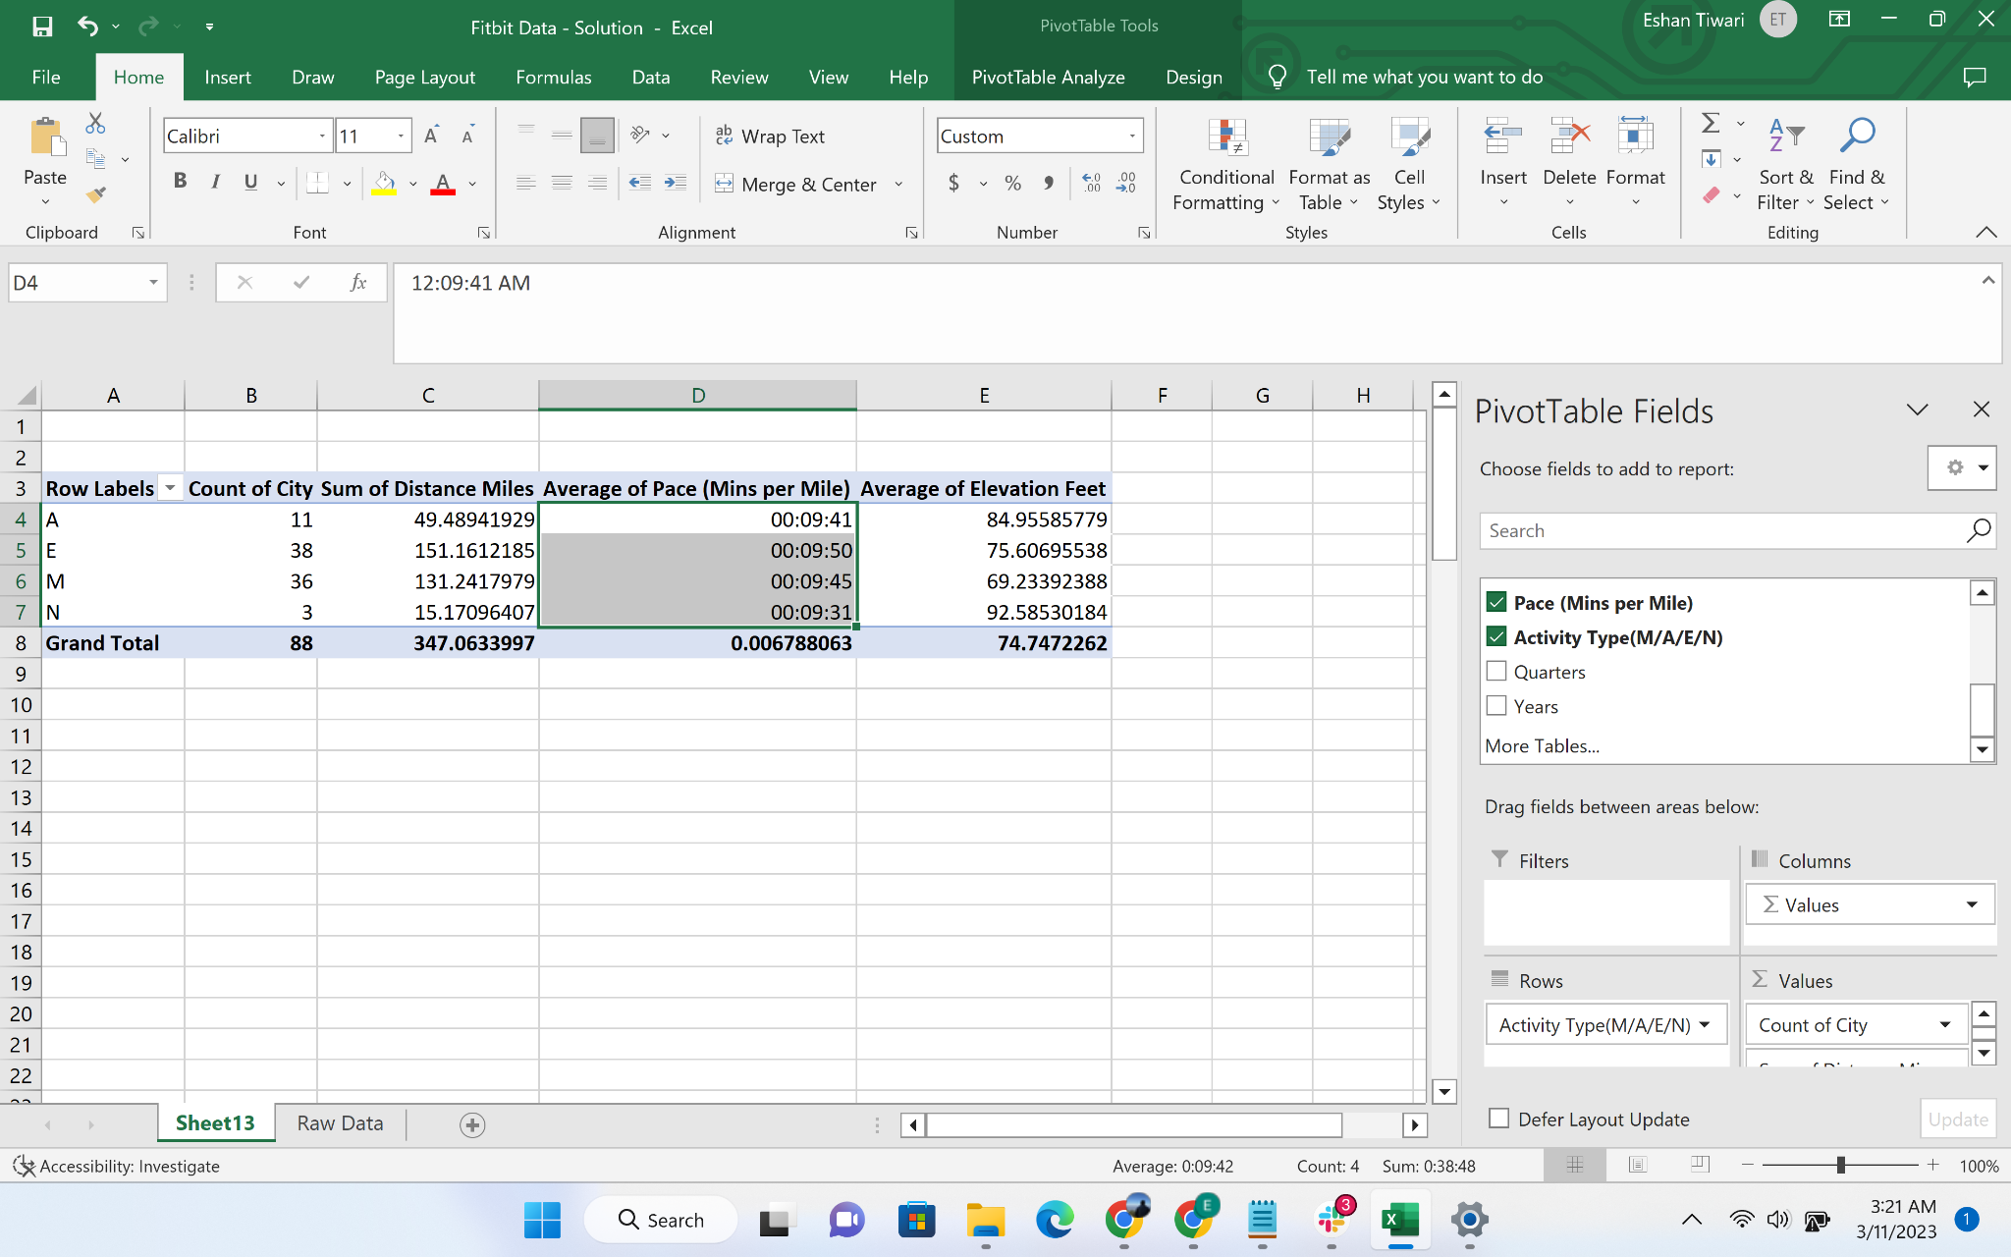

* Go to the insert slicer

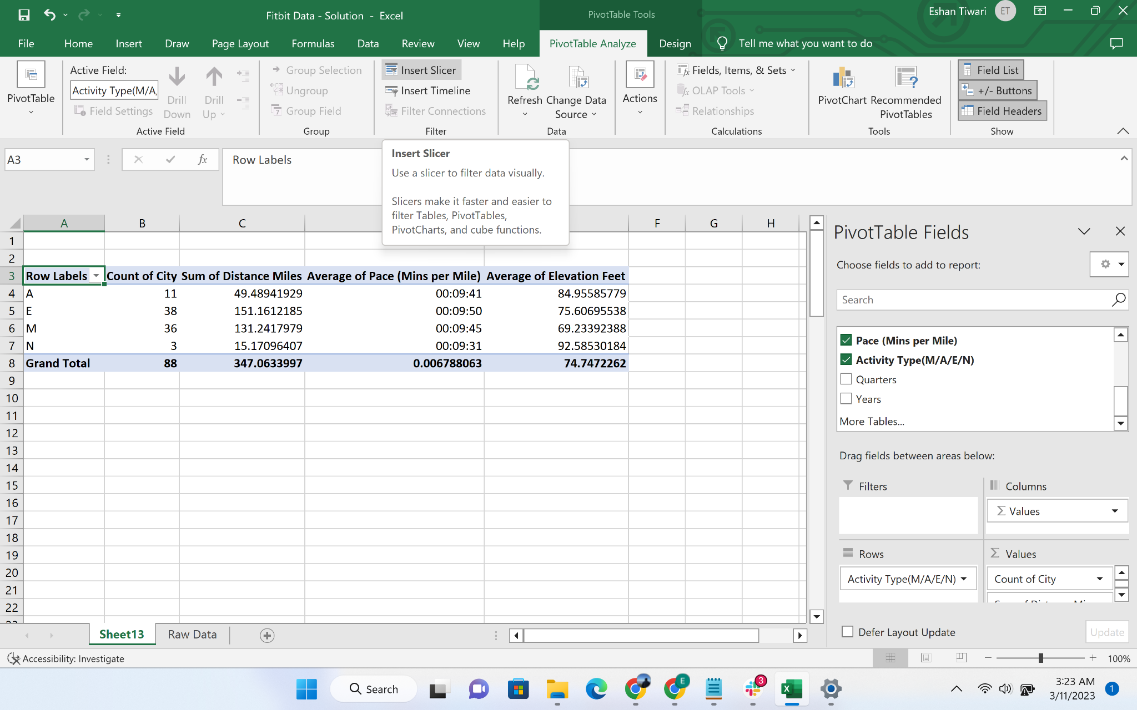

* Select date/time slicer

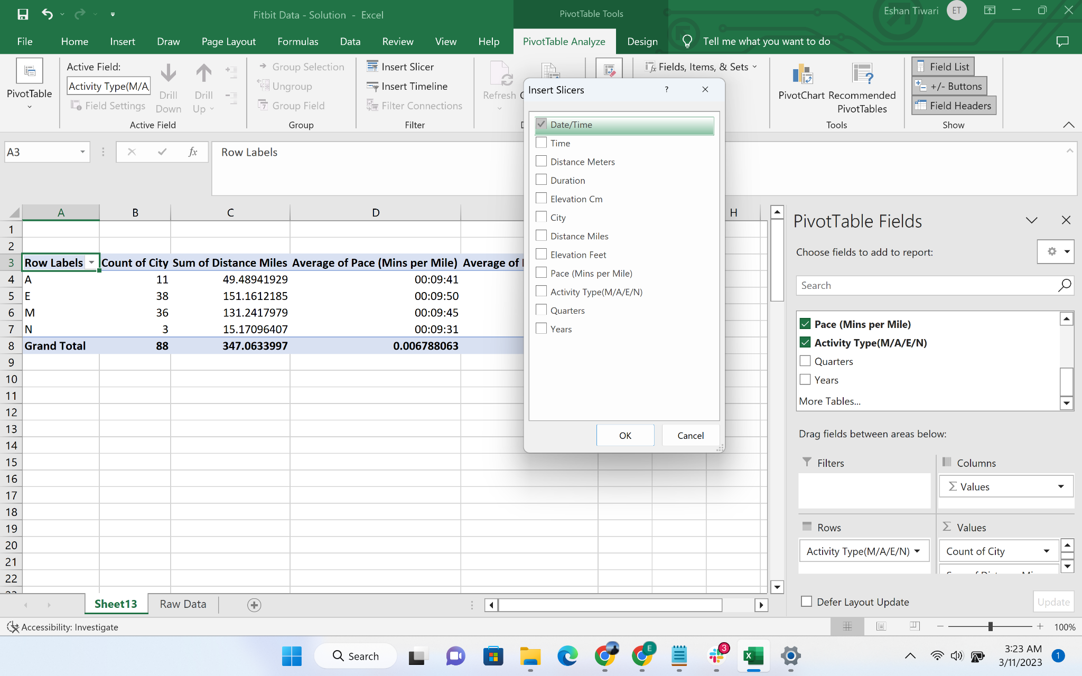

* Create another pivot table into the existing sheet - sheet 13

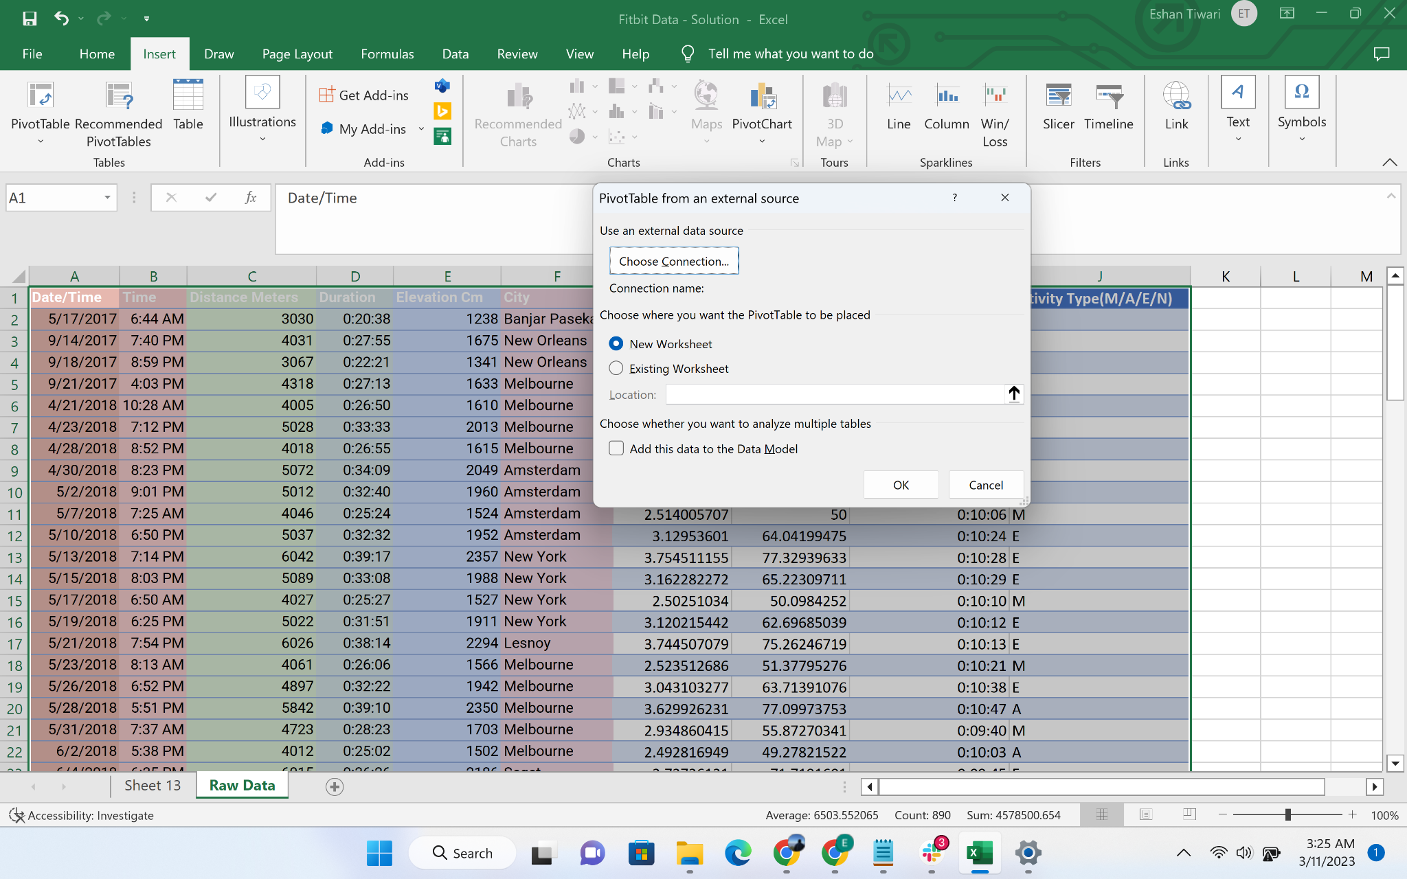

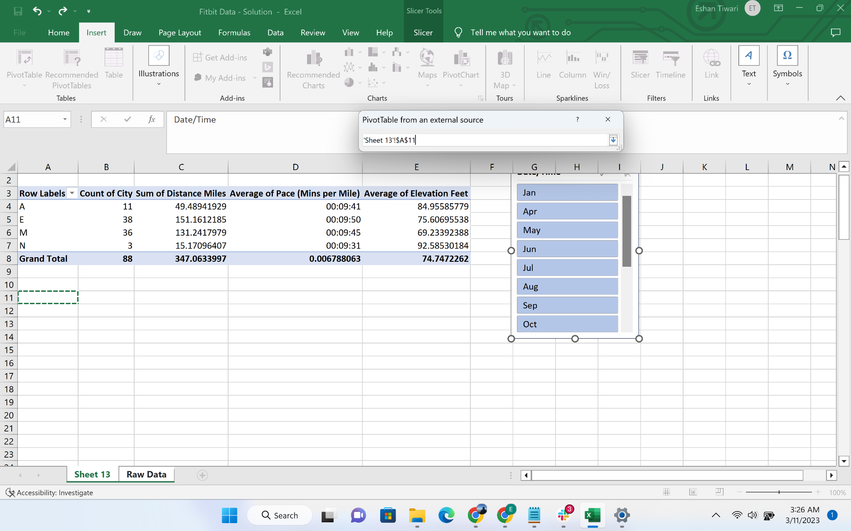

* Create a pivot table to calculate number of activity per city, then sort the data in descending order, and color code top 5 cities using conditional formatting

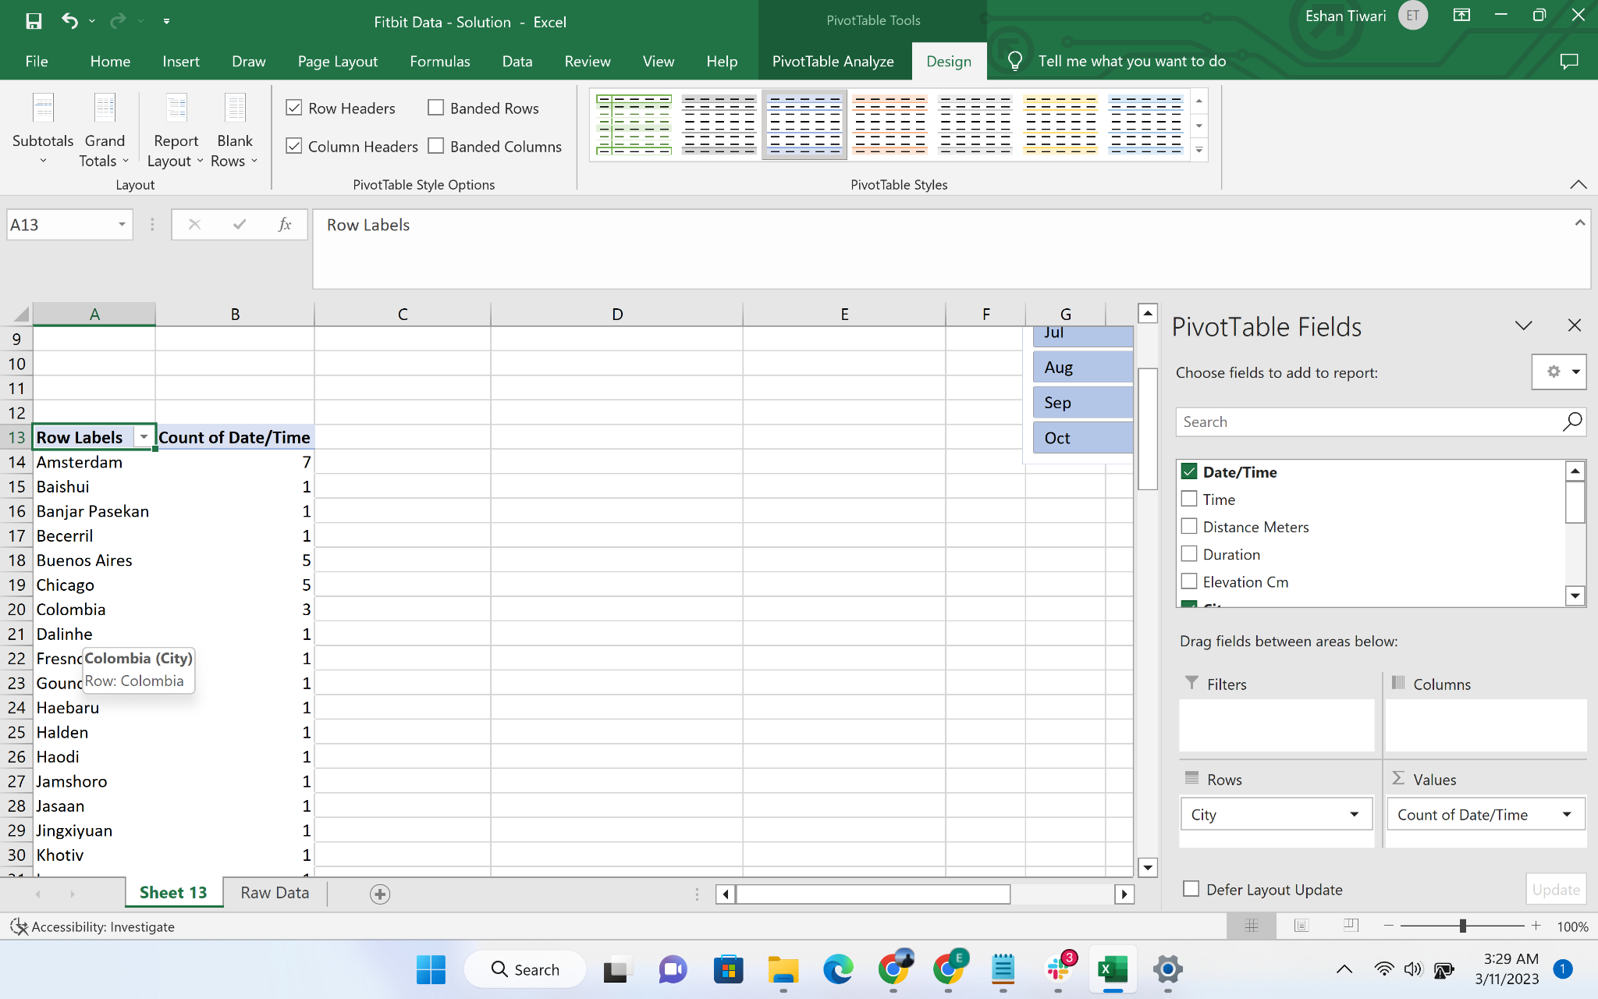

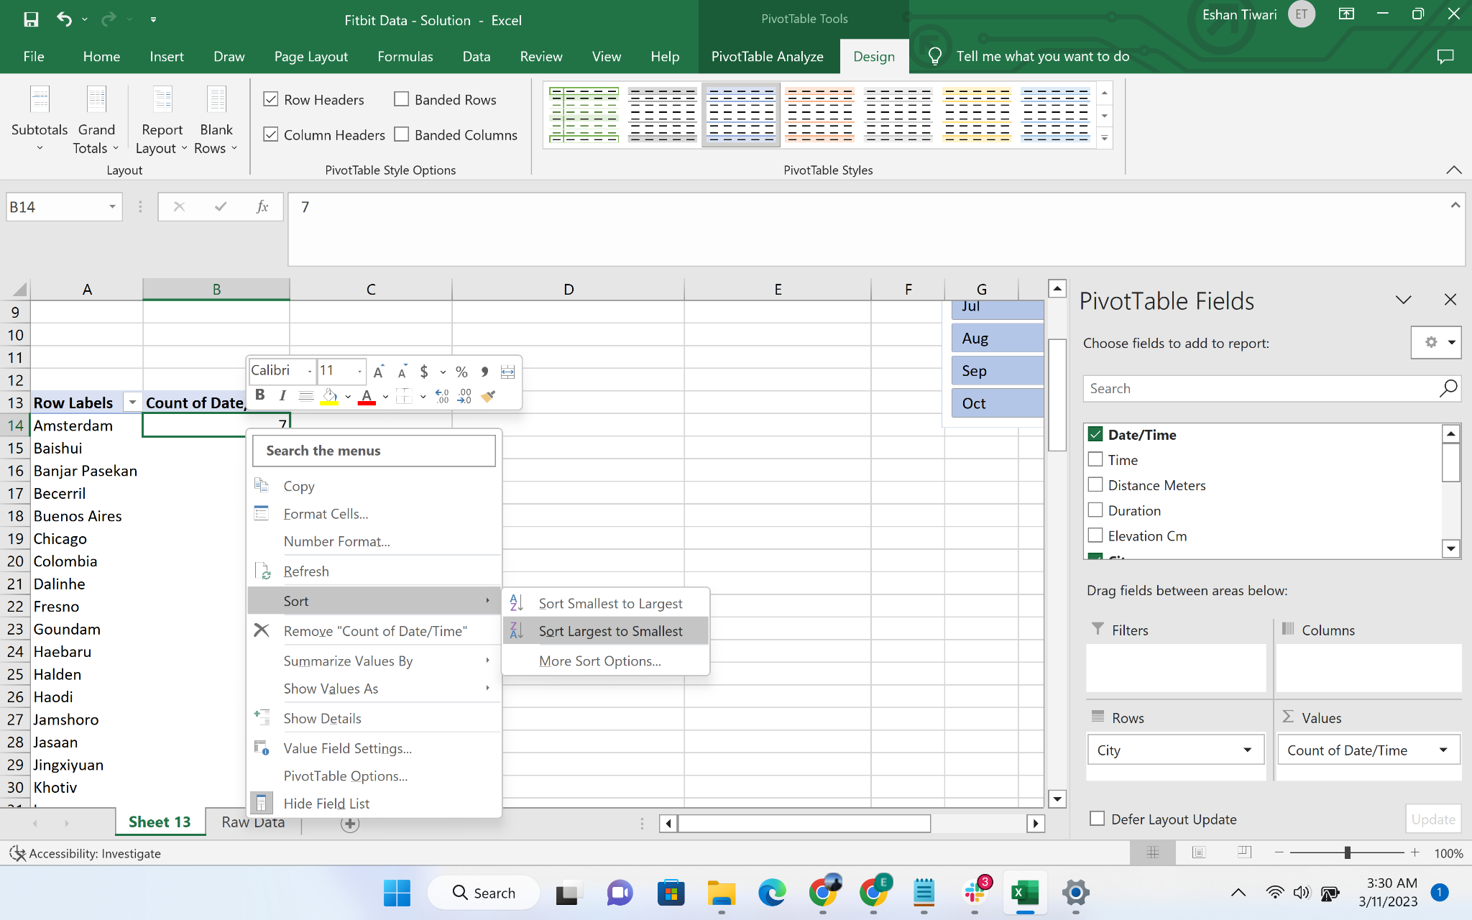

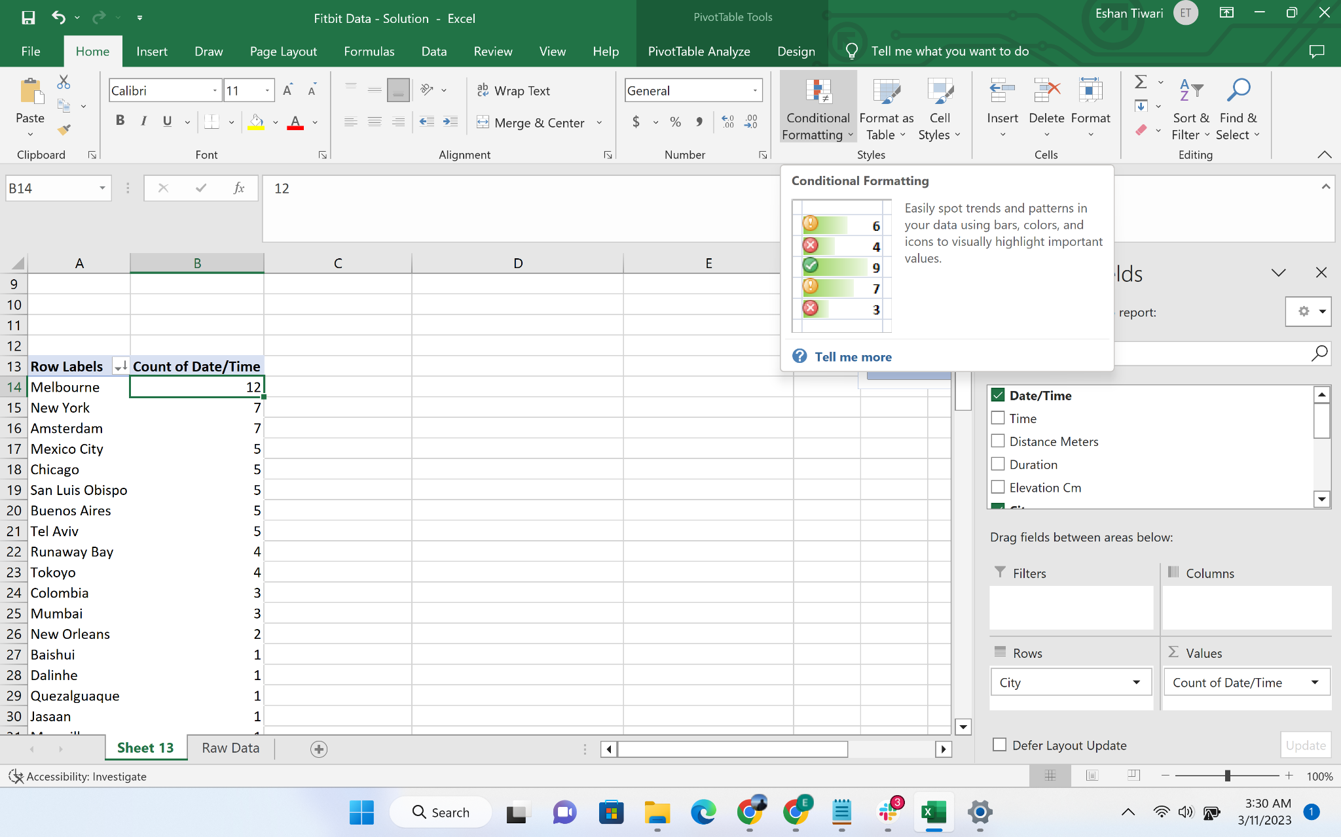

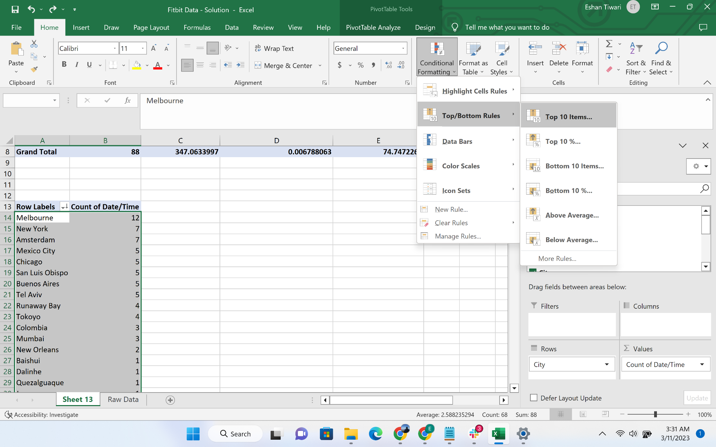

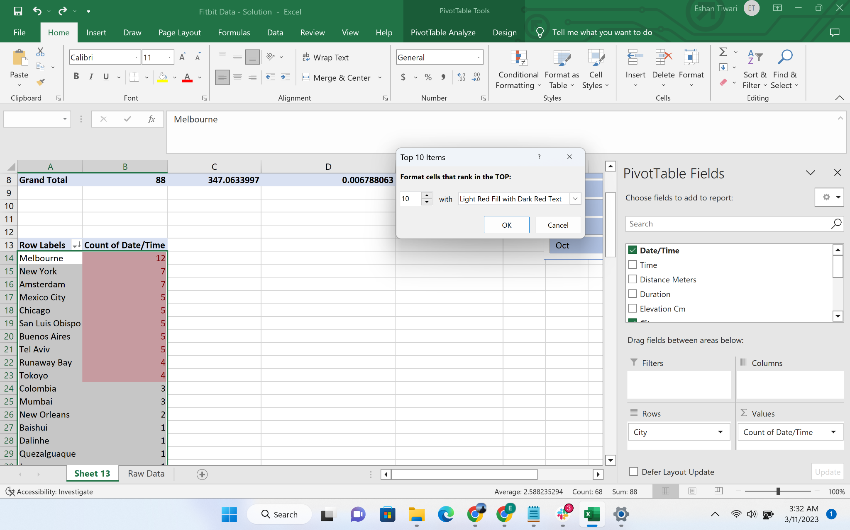

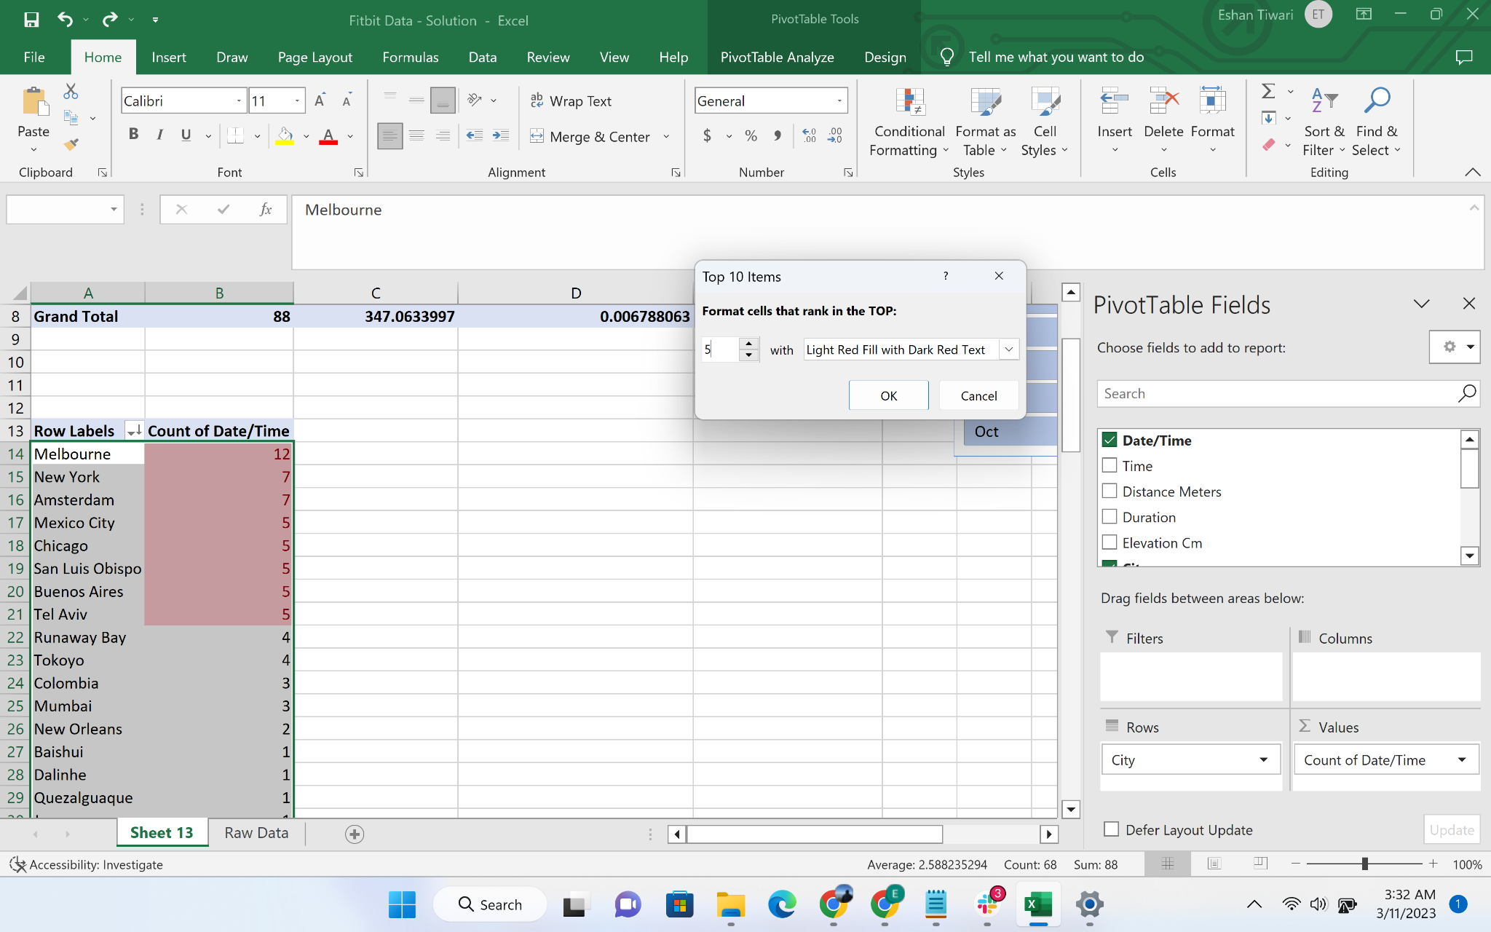

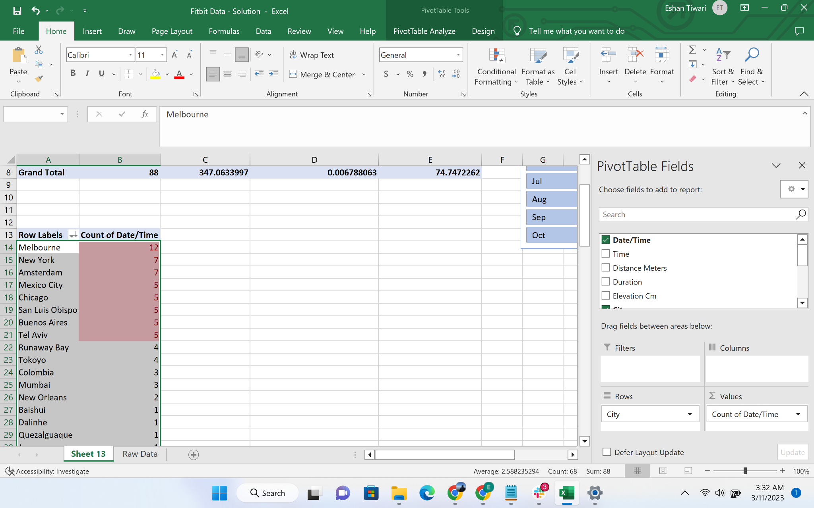

* Using pivot chart option, create a column chart for the city and activity distribution

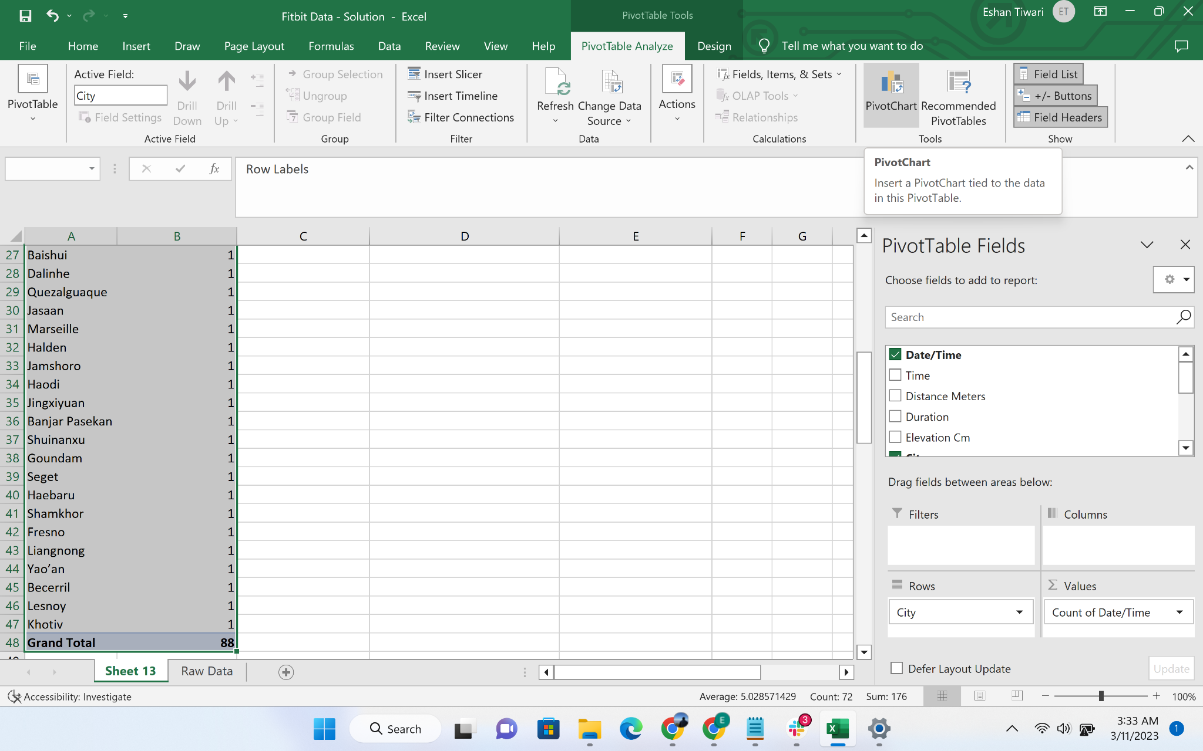

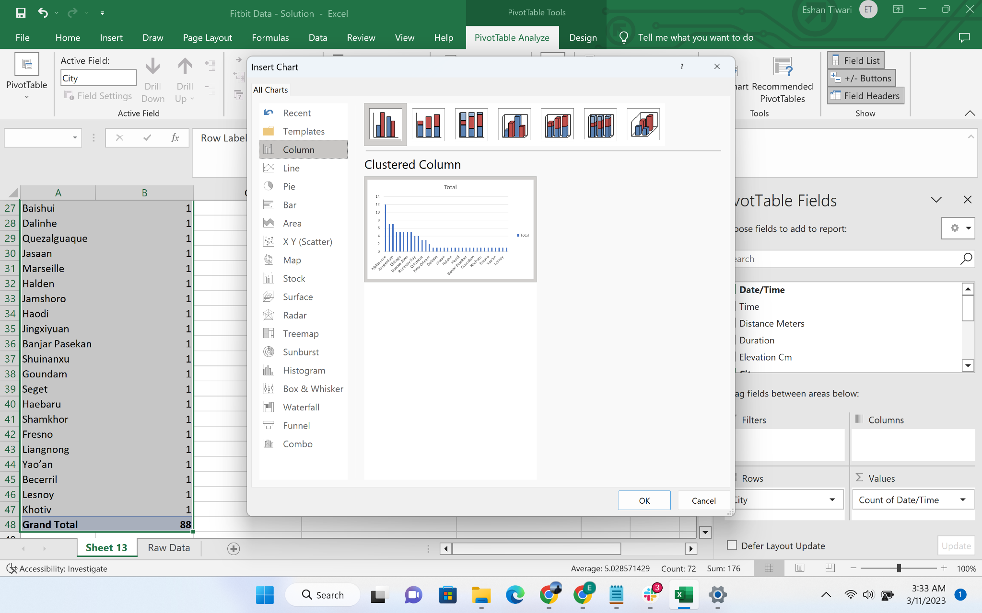

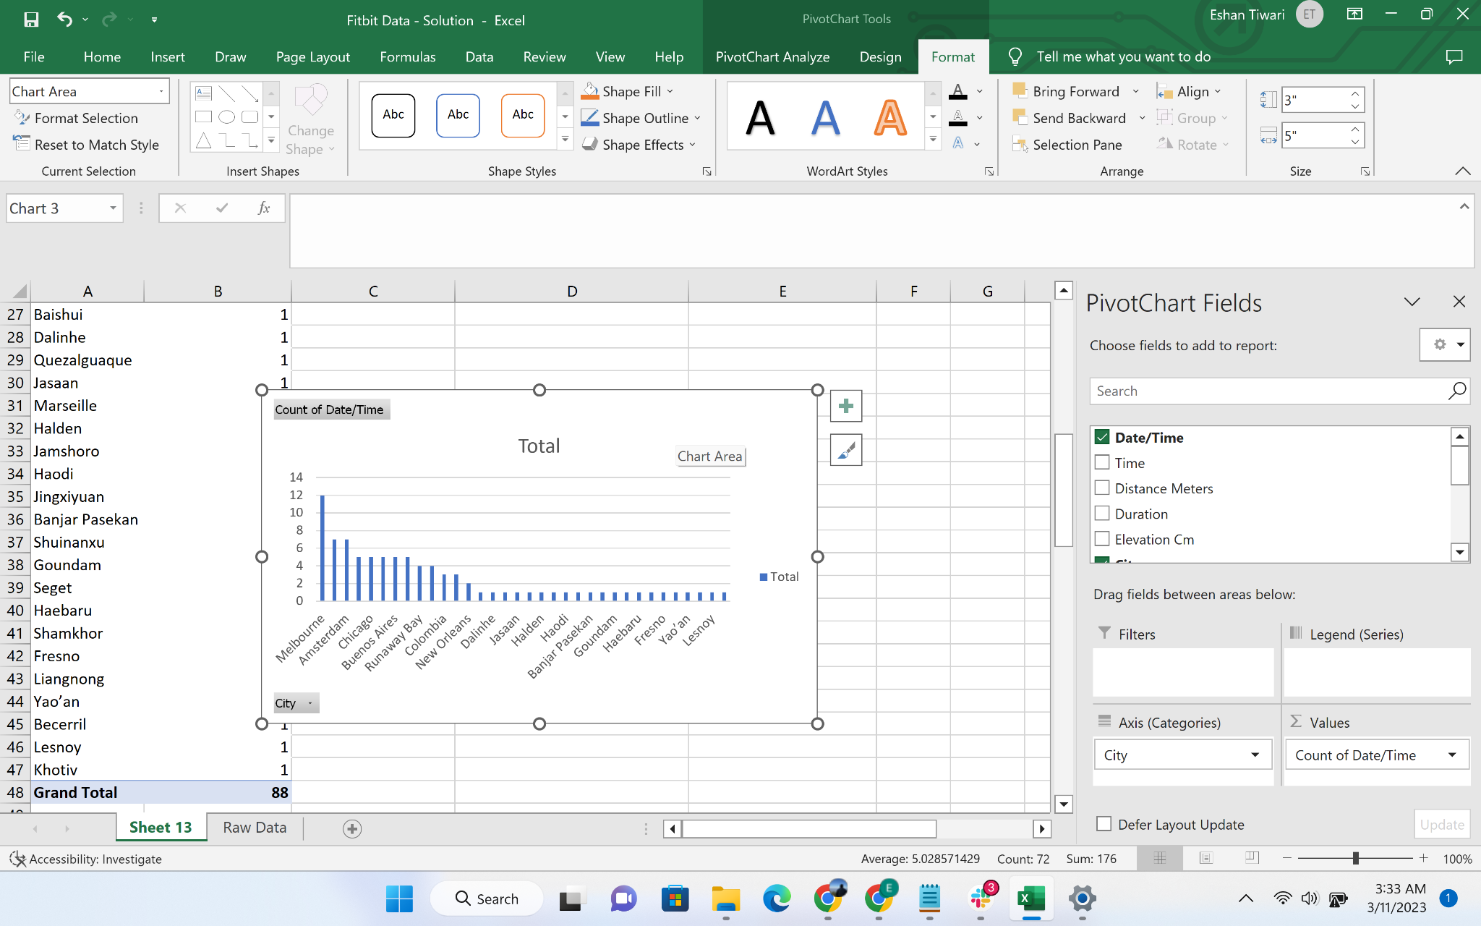

* Insert Slicer for the city name

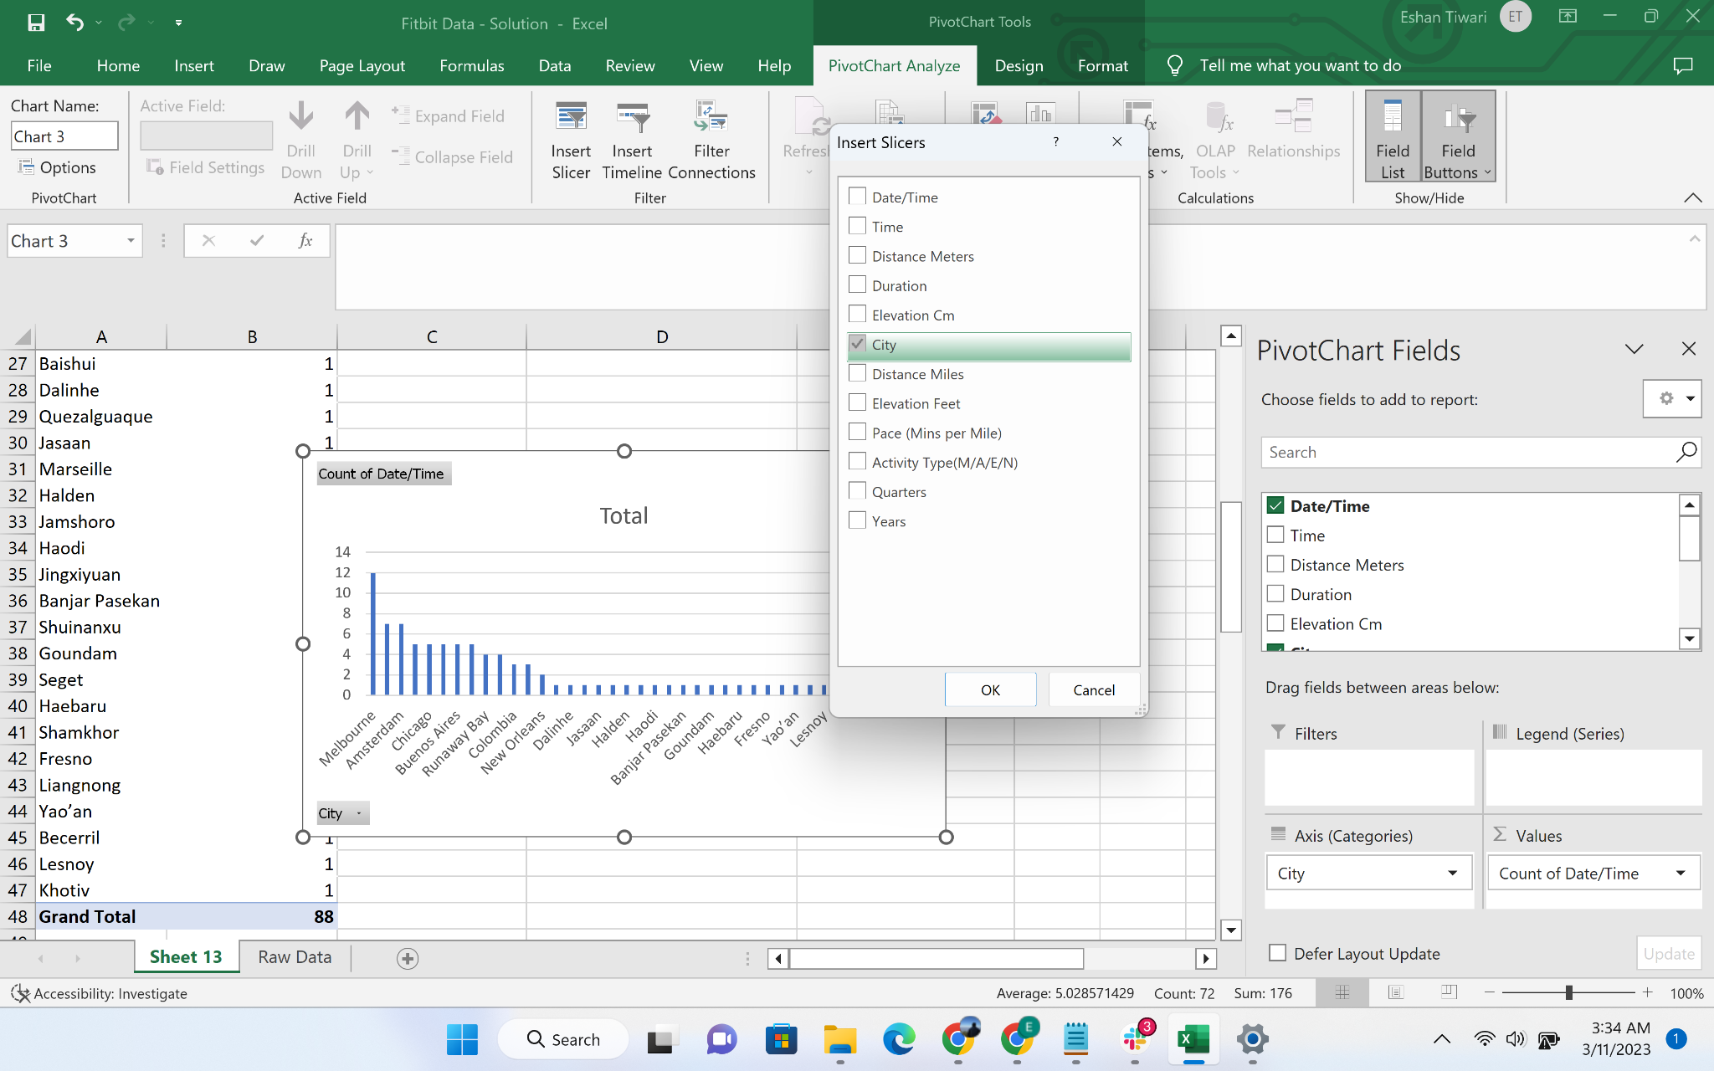

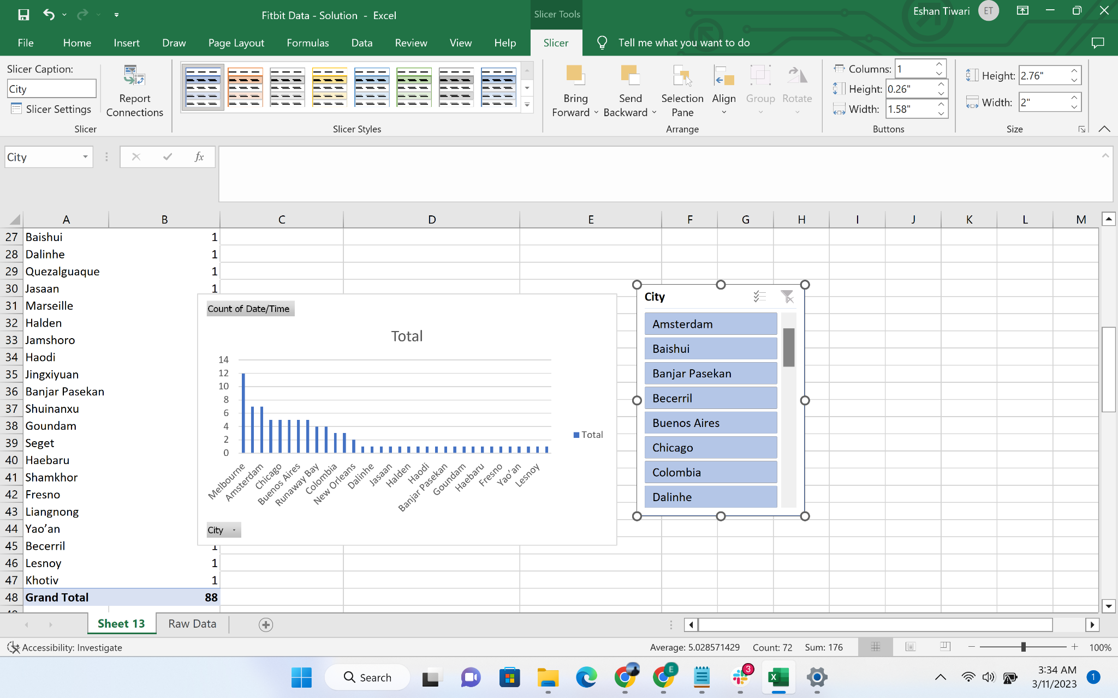

* Link the two slicers using “Report Connections”

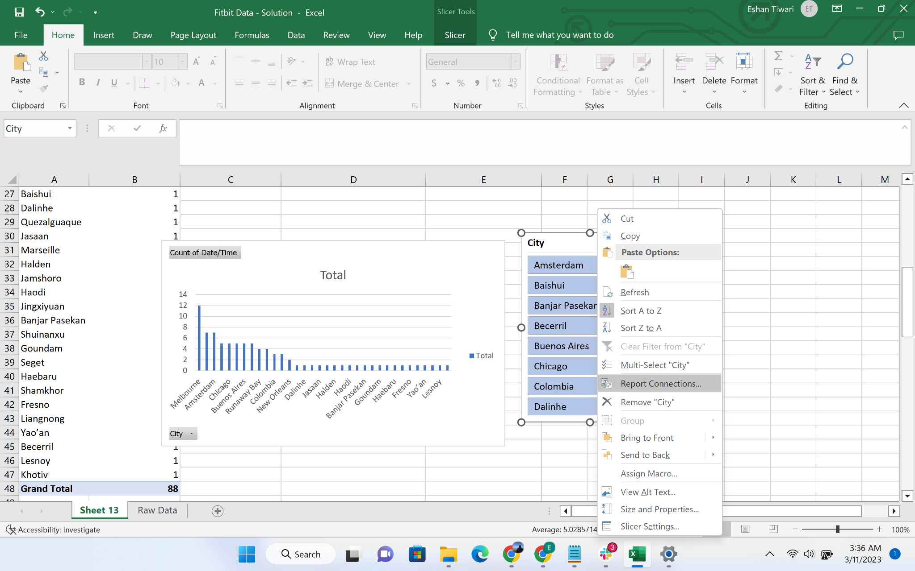

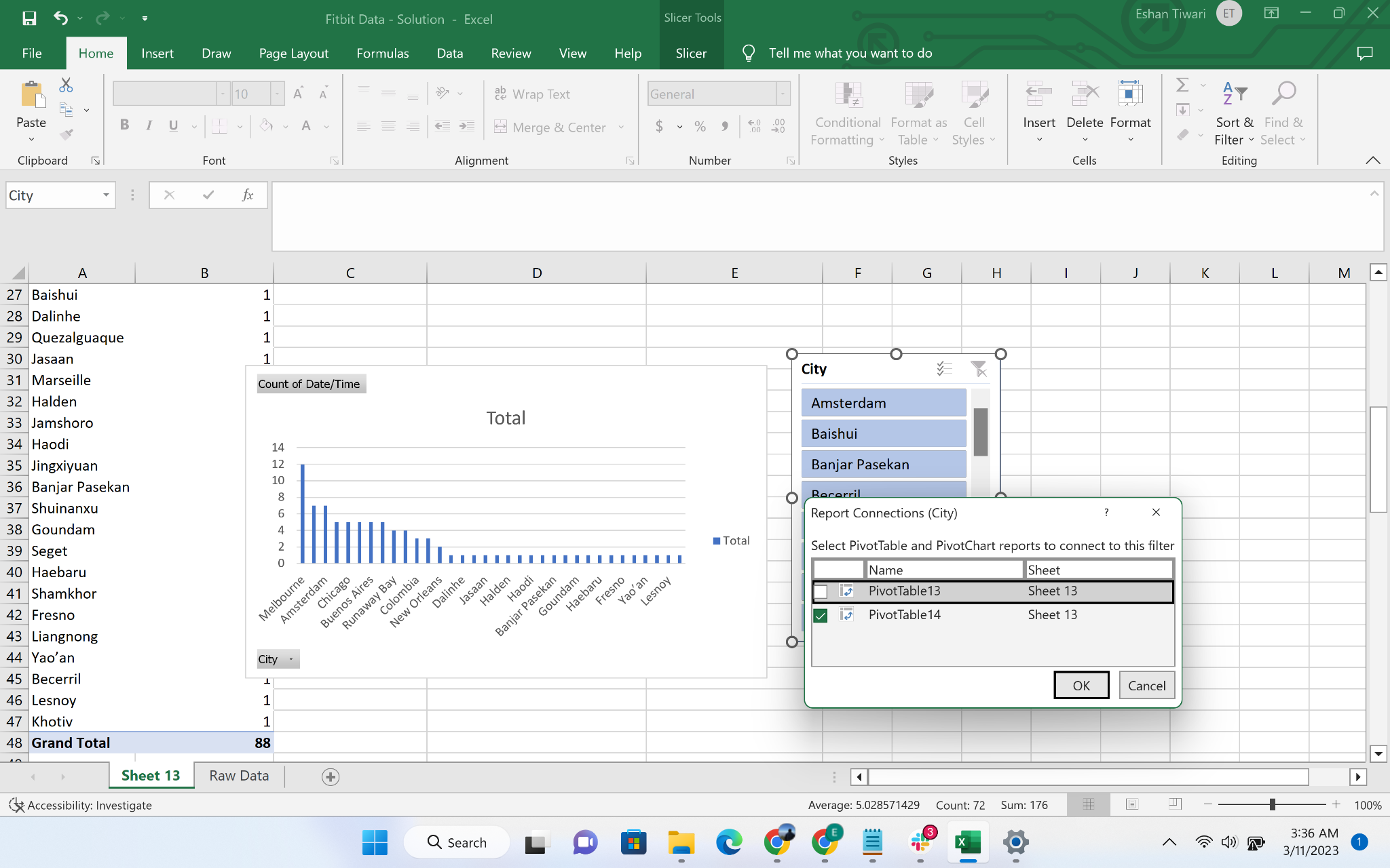

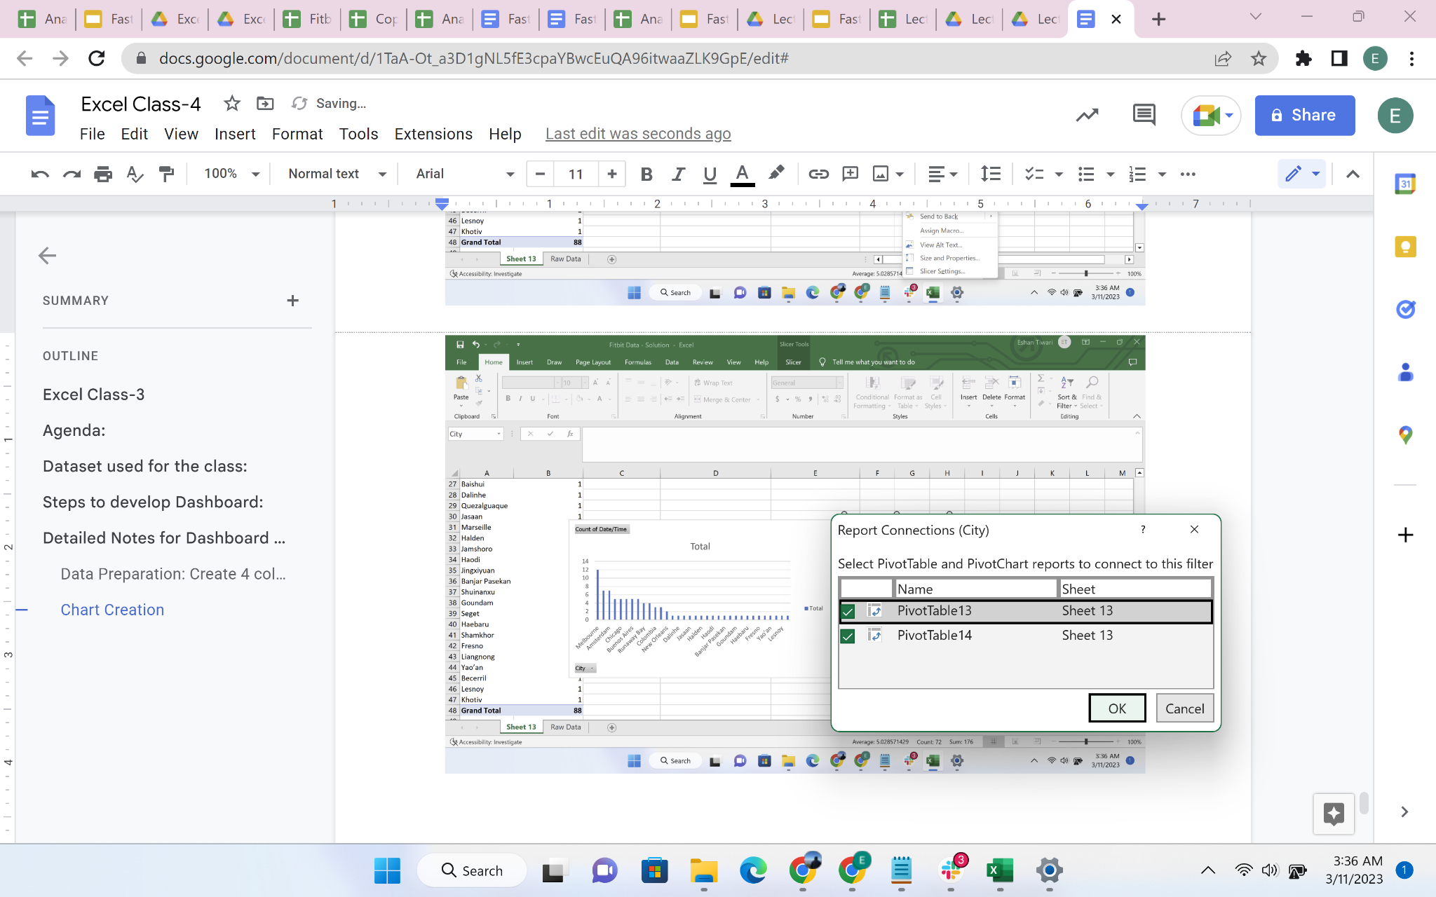

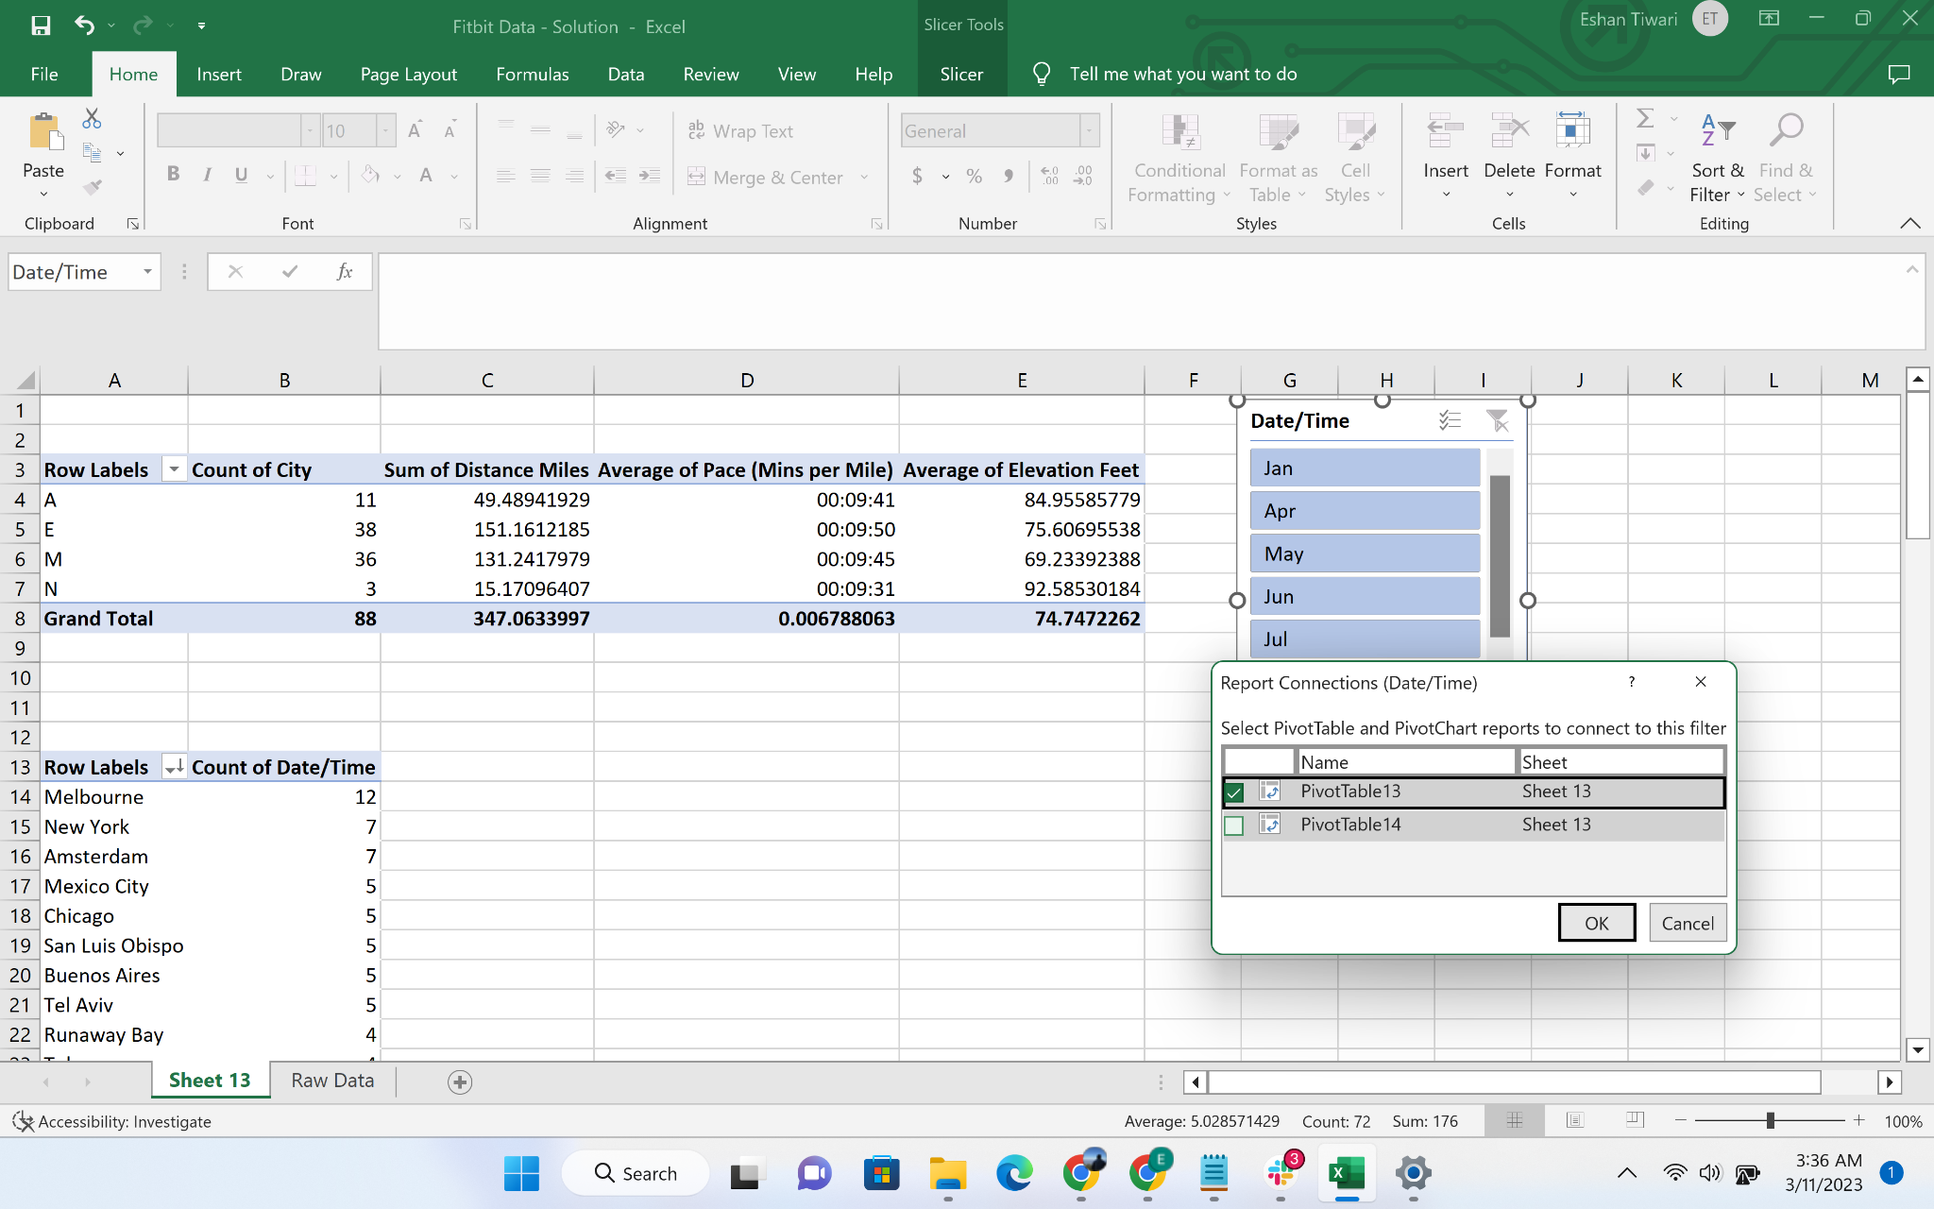

### 3. Dashboard Creation

* Copy-paste the slicer and charts on the dashboard tab

